ESHS GA Agenda with Reports and Statements
Brussels, Saturday 10 September, 17:30-19:30

ESHS officers: Theo Arabatzis (TA), Ana Simões (AS), Koen Vermeir (KV), Simone Turchetti (ST), Erwin Neuenschwander (EN), Roberto Lalli (RL), Brigitte Van Tiggelen (BvT), Liesbeth de Mol (LdM), Erika Luciano (EL), Dana Jalobeanu (DJ)

General Assembly. Agenda

17:30pm
- Election of three auditors of treasurer’s report. TA
- Election of two scrutineers (vote for the Scientific Board). TA

17:35pm
- President’s report. Vote TA
- Vice President’s report. Vote AS
- Editor of Centaurus’ report. Vote KV
- Secretary’s report. Vote ST
- Treasurer’s report and three auditors’ joint report. Vote EN
- PR Officer’s report. Vote RL
- Web Editor and Communications Officer’s report: BvT
- Webmaster’s report. Vote LdM
- Archivist’s report. Vote EL
(and other reports from individual members)

18:15pm
- President Elect’s report and plan of action. DJ

18:25pm
- Presentation of the candidates for the new Scientific Board: vote. TA, Candidates, Scrutineers

19:00pm
- Amendment of statutes. Vote TA
- Raise of membership fees. Vote TA

19:15pm
- Presentation of the recipients of the early scholar grants. TA, ST
- A preliminary assessment of the Brussels Conference. BvT

19:25pm
- ESHS 2024 Conference. Vote. TA

19:30pm
- Closure by the new President. DJ

1. Volunteers for Scrutineers: Jaume Navarro, Kostas Tampakis
2. Volunteers for Auditors: Karine Chemla, Daniele Cozzoli, [TBC].

Reports:

3. President’s Report, 2020-2022 (TA)

Running the ESHS is a heavy-duty commitment and, in the process of trying to fulfill my responsibilities as President, my admiration and awe for past Presidents and their achievements has grown immensely. The governing of the Society, though, is a collective enterprise that involves, besides the President, the vice-President, the President-Elect, and the other Officers of the Scientific Board (SB). I’ve been fortunate to have stellar scholars as fellow-travelers in this two-year journey and for much that has been accomplished they deserve full credit. Needless to say, I take responsibility for any shortcomings during my Presidency and I hope to have them amended in the near future.
The past two years have been unprecedented in recent history, because of the Covid pandemic. The pandemic gave rise to many challenges, often making in-person academic interactions impossible, but it also created new opportunities by speeding up the virtual transformation of academic activities. We have taken full advantage of those opportunities to facilitate the continuous and more effective collaboration among the members of the SB. Back in the days of physical travel the SB met only a few times, mostly over the ESHS biennial conferences and in-between meetings, whereas for the past two years we met regularly, roughly every two months, and for a total of twelve times!
This gave us an opportunity to discuss all the pending issues of the ESHS and try to address them promptly. The issues that occupied us the most included the official journal of the Society, the expansion of its membership, the improvement of its website, the opening of an ESHS bank account, the awards and financial support that it offers to senior and early career scholars, and, last but not least, its conferences: the 2021 in-between meeting in Athens, the 2021 Early Career Network Conference, and the 2022 conference in Brussels.
Here is an overview of what has been done over these two years:

ESHS Conferences
ESHS Athens 2021 in-between meeting
In the Lisbon 2019 in-between meeting I suggested “History of Science and the Humanities” as a theme for the in-between meeting of ESHS that would take place in Athens in the fall of 2021. I also explored the possibility of getting the Research Centre for the Humanities https://www.rchumanities.gr/en/) involved in the organization and hosting of the in-between meeting of the Society in Athens. The response of the Centre was very positive and, thus, the Athens meeting was co-hosted by the Department of History and Philosophy of Science at the National and Kapodistrian University of Athens, where I am based, and the RCH.
In-between meetings are called thus because they take place between the big biennial conferences of the Society and their purpose has been partly academic/intellectual and partly administrative. We originally planned to have the Athens meeting as an in-person event, but we had to change our plans because of the pandemic. There was a plus side to holding the meeting as an online event: it could now be accessible to all the members of the ESHS and the history of science community at large. The meeting took place virtually and attendance was free for everyone.
One of the aims of the Athens meeting was to make the history of science more visible in the humanities landscape and to rethink our relations with other humanistic disciplines: First, by discussing how history of science fits within the rich constellation of the humanities, which have themselves been facing various challenges and opportunities. Second, by reflecting on how history of science, and the humanities more generally, can be brought to bear on wider and socially relevant issues, such as the digital condition and the Open Access of research findings, the rise of fake news, post-truth, and science denialism.
The speakers at in-between meetings are of two kinds: members of the SB of the ESHS and invited speakers, distinguished scholars who are outside the governing structure of the ESHS. In the Athens meeting we had an impressive line-up of speakers, including prominent members of the ESHS Scientific Board and eminent members of the History of Science Community at large:
Maria Paula Diogo & Ana Simoes, Sven Dupré, Kostas Gavroglu, Michael Gordin, Matthieu Husson, Dana Jalobeanu, Erwin Neuenschwander, Chris Newfield, and Koen Vermeir gave stimulating talks that were well-attended and gave rise to interesting discussions. Recordings of their talks are available at the ESHS website.

ESHS Athens 2021, Second Early Career Scholars Conference (https://eshsathens2021.wordpress.com/)
This conference was organized back-to-back with the ESHS in-between meeting. It had been scheduled as an in-person event, that would be hosted by the Department of History and Philosophy of Science at the University of Athens and the National Hellenic Research Foundation. Again, due to the challenges of the pandemic, it was decided to hold it online. The ESHS has supported (and will support) wholeheartedly the Early Career Scholars conferences, the aim of which is to provide a discussion forum for early career scholars. The topic of the Athens conference was “Science and its Enemies: Exploring Conflicts and Alliances in the History of Science”. The organizers put together an excellent program (available at https://eshsathens2021.wordpress.com/agenda/), which testifies to the vibrancy of the Early Career Scholars Network.
I was kindly asked by the organizers to give a keynote lecture at the meeting. Because I hadn’t worked on the theme of the conference, “Science and its Enemies: Exploring Conflicts and Alliances in the History of Science”, I had to think of a topic to address that would be relevant to that theme. It gradually dawned on me that the history of science as a field could be (and indeed has been in the so-called Science Wars) considered as an enemy of science. In particular, some aspects of the taken-for-granted methodology of history of science can be easily mis-appropriated by the enemies of science.
The history of science has always approached science from a critical distance. And this is how it should be. All the while, it is vital for our community, especially now, when the value of the humanities is met with skepticism, to make clear that our critical attitude towards science and technology, an attitude that goes to the very methodological core of our discipline, does not make us an ally of advocates of post-truth, science-denialists, and anti-vaxxers. In the lecture I discussed this problem and argued that, while our methodology seems prima facie to support a post-truth attitude, this is not actually the case.

ESHS Brussels 2022
The theme of the 10th ESHS Conference in Brussels is “Science Policy and the Politics of Science”. The Conference is organized by the Belgian National Committee for Logic, History and Philosophy of Science, the Université libre de Bruxelles, and the Vrije Universiteit Brussel, under the auspices of the ESHS.
Because of the pandemic, there was considerable uncertainty about whether the 10th ESHS Conference could take place as an in-person event. Thanks to the persistence and the hard work of the organizers, what sounded like a remote possibility has become a reality. More than 400 participants from within and beyond Europe will take part in this Conference, which is the first in-person event of our Society since its in-between meeting in Lisbon in 2019. Out of those, 101 are graduate and doctoral students and 75 are non-presenting attendees. The following figure presents, in visual format, the composition of the conference participants.
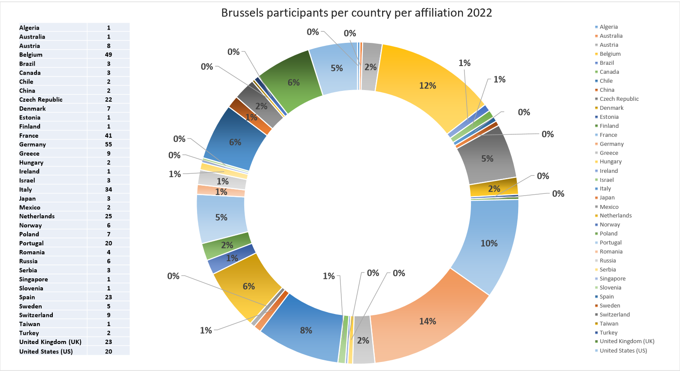

The biennial conferences of the ESHS are the most important events in the life of our Society. They play a key role in the accomplishment of its main mission: to promote excellent research in the history of science from a plurality of scholarly perspectives and to facilitate intellectual exchange and cooperation among scholars with as diverse backgrounds as possible. This Conference promises to contribute significantly to the ESHS mission. The organizers have put together a rich, stimulating, high-quality, and diversified program.
I would like to congratulate and thank warmly the organizing and the scientific committees for making possible, under challenging circumstances, such a promising event. Special thanks need to go to Kenneth Bertrams, Steffen Ducheyne, Brigitte Van Tiggelen, Renaud Bardez, Denis Diagre-Vanderpelen, Elisabeth Moreau, Roberto Raneri, Cornelis J. Schilt, Jip van Besouw, and Hannes Van Engeland for their organizational and scholarly efforts. Brigitte Van Tiggelen deserves particular mention for her smooth and excellent mediation between the ESHS and the Conference organizing committee.

Centaurus
Our official journal is the main vehicle for carrying out one of the main aims of the ESHS, the promotion of first-rate historical research on past science. In my plan of action as President-Elect I mentioned two challenges facing Centaurus: The first was to make sure that the ESHS would continue to play a significant role in the running of the journal, by exercising control over its academic content and quality. The second was the opportunities and perils posed by the Open Access (OA) initiative that was launched by the European Commission in 2018, the so-called Plan S.
Both of those challenges have been met successfully, as one may gather from the meticulous report on Centaurus, prepared by its editor-in-chief, Koen Vermeir. Meeting successfully those challenges involved a change of publishers. The Presidents of the ESHS and the Editor-in-Chief of Centaurus contemplated its move to Open Access for quite some time, but it was clear that it couldn’t happen under Wiley, its publisher until the end of 2021. So, we started to explore other possible publishing venues for Centaurus. As it happened, in late 2020 we were notified by Wiley that they intended to “close down” Centaurus and terminate their contract with the ESHS. After exchanging several emails with them it became clear that their decision was irrevocable. We offered to buy Centaurus, but they declined invoking “legal obstacles”. As we found out later, they had sold it to another publisher. Again, details about our (mis-)adventures with Wiley and how we were able to acquire joint ownership of Centaurus can be found in Koen Vermeir’s report.
Ultimately, what is important is that we were successful in reaching an agreement with Brepols, a distinguished publisher with a long tradition in the field of history of science, for relaunching Centaurus as an Open Access journal. In a nutshell, two are the most important elements in the ESHS-Brepols agreement: First, Centaurus is co-owned by the ESHS and Brepols (in contrast with its predecessor, which was fully owned by Wiley). Second, Centaurus is now published in a fully open access form, at no cost to its authors or readers. The journal is partly funded by Brepols and the ESHS, and partly through the so called Subscribe to Open model, which relies on library support for covering publication costs. Full details about this model are given in Koen Vermeir’s report. Our ambition is to make the journal sustainable, without the financial support of either Brepols or the ESHS.
I would like to thank the other Presidents of the Society and the Editor-in-Chief of Centaurus for their extensive and constructive involvement in the discussions that we had with Brepols, as well as two former Presidents of the ESHS, Karine Chemla and Toni Malet, for their significant help throughout the process of finding another publication venue for our journal.
I need to stress that the sustainability of Centaurus as a fully open access journal will depend on the active involvement of our members in it. We count on our members for promoting Centaurus to their libraries and institutions. Indeed, we hope that they will reach out to their libraries and institutions and ask them to support Centaurus by taking a “subscription” at a significantly reduced price from the current rate. These subscriptions will be essential to the long-term financial viability of Centaurus as an open access journal, freely available to the history of science community worldwide.
So far, we have attracted a low number of subscriptions (about one quarter of the subscriptions we would need in order to cover publication costs), despite our repeated appeals to our members to reach out to their libraries and institutions and convince them to subscribe to our journal. This is one of the most pressing issues facing Centaurus in the near future, an issue that will have to be addressed and, hopefully, resolved in the next years. One step in this direction would be a slight raise in the ESHS membership fees. The SB will thereby propose to the General Assembly that normal fees should be raised from 25 to 30 euros; EC Scholars fees should be raised from 15 to 20 euros; promotional rates (offered in the biennial meetings) should be raised from 30 to 40 euros (normal fees for two years) and from 15 to 20 euros (EC Scholars fees for two years).
One of the most innovative features of Centaurus is its mentorship program, addressed to younger scholars without much experience with international publishing. Until recently, the mentoring process was overseen by the editor-in-chief of Centaurus. That put the editor-in-chief in an awkward position, since he had the final say on whether a paper that has profited from the mentoring process would be published. So, the editor-in-chief and the Presidents of the ESHS thought that with the move to Brepols there was an opportunity to disassociate the mentoring process from the Centaurus editorial team and shift responsibility of it directly to the ESHS and, in particular, to its Early Career Scholars Network (ECSN). In the transition period, which lasted several months, the program was overseen by me and it has now passed to the jurisdiction of the ECSN.
In all, under the able leadership of its editor-in-chief, Centaurus has moved from strength to strength and consolidated its position as one of the top journals in the field. It deserves and will have the full support of the ESHS and I’m confident that it will continue to thrive.

Early Career Scholars
Part of the mission of the ESHS is to support young scholars, who nowadays find themselves in dire professional circumstances and may lack adequate resources to promote and publish their research. For this reason, we give several Travel Grants to early career scholars, so to enable them to attend the Society’s meetings. The early career scholars who have been offered grants for covering part of their expenses to travel to Brussels and attend the ESHS 2022 conference are listed in this Agenda.

Another way in which we support the ECSN is by giving the opportunity to very promising young scholars to present their work at the Society’s biennial conferences through the “Early Career Lectures” awards. This year the recipients of those awards were three very talented and innovative scholars:
- Gemma Cirac-Claveras, Universitat Pompeu Fabra
- Sam Robinson, University of Southampton
- M. Luísa Sousa, Interuniversity Centre for the History of Science and Technology (CIUHCT) and NOVA University of Lisbon

Information about their biographies and research can be found at the Society’s website (http://www.eshs.org/2022-early-career-plenary-lectures/)
The Early Career Scholars Network is crucial for the future development of the ESHS. In light of its expansion and the excellent work that has been done by its members, we have decided to propose a new position on the ESHS Scientific Board: Representative of the ECSN. We think it is necessary to have that position so as to strengthen the relations between the ESHS and the ECSN.

Gustav Neuenschwander prize 2022
The Gustav Neuenschwander Prize is the main prize of the ESHS and is given in recognition of outstanding lifetime achievements and major contributions to the history of science. This year’s award has been given to Simon Schaffer, a brilliant scholar whose path-breaking, wide-ranging, and stimulating scholarship has inspired successive generations of historians of science to this day. Full details about the 2022 GN Prize can be found at the ESHS website: http://www.eshs.org/2022/06/08/gustav-neuenschwander-prize-2022/
We are grateful to Erwin Neuenschwander, whose generosity and devotion to history of science have made this award possible.
Membership
Before the Brussels conference the ESHS had close to 600 members:
ESHS members per country per affiliation 2022
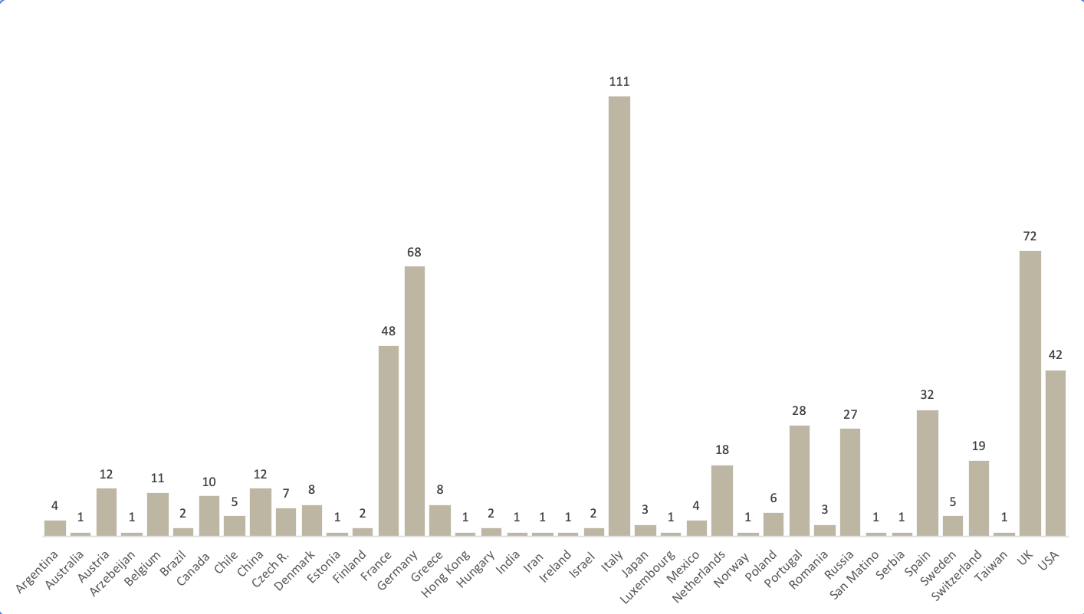

407 scholars from 39 countries have registered for the Brussels conference:Brussels participants per country per affiliation 2022

The participants of the Brussels conference will become new members of the ESHS. One of the challenges for the next two years is to attract new members beyond those participants.

In the past two years, thanks to the sustained efforts of our PR Officer, Roberto Lalli, we have been able to attract several new institutional members:

- Belgian-Dutch Society for the History of Science and University (GEWINA)
- Catalan Society for the History of Science and Technology
- French Society for the History of Science and Technology (SFHST)
- Institute for the History of Science at the Autonomous University of Barcelona
- Interuniversity Centre for the History of Science and Technology, Lisbon
- Italian Society for the History of Mathematics (SISM)
- Italian Society for the History of Physics and Astronomy (SISFA)
- Italian Society of the History of Science (SISS)
- Max Planck Institute for the History of Science
- Russian Society for the History and Philosophy of Science (RSHPS)
- Science History Institute
- Society for the History of Alchemy and Chemistry (SHAC)

In the coming years, we plan to pursue joint initiatives with our institutional members. This will be important for providing more opportunities for the interaction and collaboration of historians of science in Europe and beyond.

Website
Our previous website had an outdated design and could not fully support the ESHS’ activities and initiatives. Furthermore, it was hosted by a server that was not controlled by the Society and this made the Webmaster’s job more difficult. We had the good fortune to have Liesbeth de Mol as webmaster. Liesbeth, almost single-handedly, developed a new beautiful and functional website (http://www.eshs.org/) and arranged for it to be hosted by a new server. We are all indebted to Liesbeth for such a fantastic work! She deserves a huge thanks.

Archive
The ESHS archive was in paper form and included a wealth of documents concerning the history of the Society (Statutes, minutes of Council meetings, etc.). As a result of the tireless work of Erika Luciano, the entire archive has now been digitized. Thank you, Erika.

Things that remain to be done: Statement for 2022-2024
Some time ago, the ESHS Council had received a proposal from our colleagues in Russia to host the 2024 ESHS meeting in Moscow. The proposal was reviewed and tentatively accepted by the ESHS Council, and received a final approval by the General Assembly at the 2020 ESHS Bologna meeting. The outbreak of the war in Ukraine, however, has forced us to reconsider our plans and to look for another venue for the 2024 ESHS meeting. In April we began to explore various possibilities for organizing that meeting in another European country. Those informal explorations did not lead anywhere, so in June we issued a formal call for expressions of interest in hosting 2024 ESHS. So far, we have received only one informal expression of interest, which however has not led yet to a detailed and credible proposal. We will thus ask the General Assembly at the Brussels Conference to grant us more time to come up with a suitable venue (by the next in-between conference, at the latest).

Bank Account
For several years we have been trying to open an account in a French Bank (BNP). Our vice-President, our Treasurer, a former President (Karine Chemla), a member of the SB (Matthieu Husson), and myself have spent a lot of time and effort to overcome the hurdles posed by the impossible bureaucracy of the French banking system. After many visits to the bank and the signing of countless papers, we were (mis-)led to believe that the bank account was about to be opened. Unfortunately, though, at the very last minute our efforts came to nothing. We received a notification from the BNP that they had decided not to open a bank account for us. No explanation offered!
Our Treasurer continues to explore various possibilities and after the Brussels conference this should be a top priority, since a new bank account may enable payments to the ESHS via credit card and, thus, facilitate the subscription process.

Coda
Before I end this report, I would like to say a few words about the ongoing brutal war in Ukraine, which already has terrible consequences for that country, for Europe and the World at large. In the past we avoided taking a stance on political issues. In this case, though, we felt compelled to issue a statement condemning the invasion of Ukraine and affirming our strong belief that differences among nations should be resolved without the use of force. Our statement is available at http://www.eshs.org/2022/03/01/eshs-statement-on-ukraine-crisis/. It has also been endorsed by the HSS (https://hssonline.org/news/598234/HSS-Endorses-Statement-of-the-European-Society-for-the-History-of-Science-on-the-Ukraine-Crisis.htm#:~:text=We%20stand%2C%20together%20with%20other,military%20aggression%20of%20its%20government).
The accomplishments of our Society testify to what can be achieved by the cooperation among people from diverse national backgrounds, who share a commitment to dialogue and tolerance.
In closing, I would like to express my heartfelt thanks to Ana Simões, Dana Jalobeanu, Koen Vermeir, Simone Turchetti, and the other officers of the ESHS for their extraordinary commitment to our Society and their hard work towards fulfilling its mission. Special thanks also to our Treasurer, Erwin Neuenschwander, for his amazing generosity and support for our Society.

4. Vice-president report - A six-years involvement (AS)

This report caps the reports I wrote as president-elect (2016-2018) and as president (2018-2020). They are available on-line at the ESHS website as part of the minutes of the General Assembly of 2018 and 2020, respectively, and I invite you to (re-)read them here.
I am summarizing in what follows what I consider more relevant in my six-years involvement with the leadership of the ESHS, in terms of accomplishments and major pending actions.
At every time, the ESHS is headed by a triumvirate constituted by the president-elect (or president-to-be), the president and the vice-president (who has stepped down as president). In this six-years experience I worked jointly with Karine Chemla, Toni Malet, Theo Arabatzis and Dana Jalobeanu in an atmosphere of open partnership and collegiality, in which we all learned from each other how to serve in the best possible ways the aims of the ESHS. This was done together with the members of the Scientific Board, and I want to stress the role of Simone Turchetti who has been Secretary for the past four years, and is now running for president-elect, commanding the inner workings of the ESHS as few in the past did, and Erwin Neuenschwander, our Treasurer, member of the Society since its creation, the scholar behind the prestigious Gustav Neuenschwander Prize recognizing life-long achievements in our discipline, and a staunch supporter of our Society.
In these past three years the ability of the Scientific Board to work more efficiently than ever was an indirect consequence of the pandemics and of our necessity to command quickly communication via virtual platforms. In this period, exchange of mails and phone calls were outrun by regular meetings on-line, and this has made a tremendous difference in the cohesiveness of the Scientific Board and in its efficiency.
I ended my report as president commenting that various priority actions of my mandate were still ongoing (and unfortunately one still is). The initial steps in revamping the Society’s former website and in improving the quality of the old journal Centaurus have been successfully overcome in extremely positive ways: the ESHS has a new website created by our webmaster Liesbeth de Mol and housed in a server controlled by the Society. Relations with Wiley have ended, and the ESHS is now proud to co-own, together with Brepols, a diamond open-access new Centaurus (free for authors and readers), which due to the professionalism and stamina of its editor-in-chief Koen Vermeir, has become the journal in the history of science better positioned in terms of bibliometric indexes (see Koen Vermeir’s report). These two factors – open-access and high quality reflected in bibliometric terms – make it of immense appeal for early career scholars, and a signpost of thematic and methodological orientations in our discipline. I am proud to have participated in all these actions. Unfortunately, the Society has been so far unable to open a bank account in France, with major implications for handling registration fees and for looking for sources of financial support for the ESHS, deemed especially important in the new open access environment of its official journal.
In the end of my mandate as president I was also happy that Simone Turchetti was willing to serve a second term as Secretary and then to be candidate to President-Elect, and that our Russian colleagues were considering seriously to put forward a proposal to organize the 11th ESHS meeting in 2024 in Moscow. But in the meantime, the geopolitical scenario changed dramatically with the Russian invasion of Ukraine, and this possibility vanished. The ESHS was one of the first scientific societies in our discipline to issue a Statement on the Ukraine crisis, published on 1 March 2022, supporting the people of Ukraine, while at the same time saluting those in Russia, including some of our society members, who were protesting the military aggression of their government. Among them, a special word of encouragement and of esteem to Dimitri Bayuk and to Darya Drozdova, with whom I worked more closely.
The flagship of my six-years commitment to the Society – drive towards plurality in all its dimensions (geographic-, career-, gender-, thematic-, and methodological-wise) – was announced by the theoretical considerations put forward in my Presidential Address titled “Looking back, stepping forward. Reflections on the sciences in Europe” (published in Centaurus 61 (2019), 254-67, DOI: 10.1111/1600-0498.12215), in which I advocated the position that one of the main challenges for the ESHS is to return its historical gaze to Europe, while at the same time fiercely repudiating Eurocentrism, to show how much the building of the European space was never a prerogative of a few regions or a small set of countries, but was – very much to the contrary – the result of complex interactions between diverse spaces and cultures, not only intra-European but also non-European. That is, I pointed that there was still ample room for narratives of historians of science discussing the broad range of past scientific contributions. This awareness grounded my belief in the role of the ESHS as a hub for communities of historians of science eager to enhance diversity of themes and approaches in our gaze at the historical past of the sciences in Europe globally conceived.
This rationale was behind two projects which I materialized during my vice-presidency: 1) the survey “Mapping the European Society community”, which is on-line at http://www.eshs.org/wp-content/uploads/2021/11/Survey_-Mapping-the-ESHS-Community_14-Dec-2020.pdf.
The Wiley old Centaurus’ site houses “Mapping the ESHS community. A brief summary”, co-authored with Maria Paula Diogo (Centaurus 63 (2021), 452. DOI: 10.1111/1600-0498.12395), in which we cursorily introduced the survey. This survey enabled to characterize the membership profile of the ESHS and identify its major shortcomings. Summing up, diversity is at ESHS’s core but there is still work to be done to make it more attractive to early career scholars. However, I believe that the dynamism of the ESHS Early Career Network, the Centaurus’s mentorship program for early career authors, the journal’s high quality and the recent open access format are all measures meant to attract early career and junior scholars and therefore I believe they will be able to overcome the major shortcoming identified in the survey;
2) The second Centaurus’ Virtual Issue, preceded by an Introduction titled “Historiographical reflections on Sciences in Europe: Perspectives from Centaurus”, and once again co-authored with Maria Paula Diogo (Centaurus 63 (2021), 824-829. DOI: 10.1111/1600-0498.12417) aimed at identifying and analyzing contributions (papers, thematic special issues, spotlight sections) from 2007 onwards, when Centaurus became associated with the ESHS, that chose to tackle specifically historiographical reflections on sciences in Europe. As we said in the introduction “our long-lasting interest in this problematic, and the urgency of (re)addressing it in a very dynamic disciplinary scenario marked by global studies, and more generally by the necessity of exploring multi-disciplinary connections, provides the springboard for this second virtual issue.”
Let me thank Theo Arabatzis, Dana Jalobeanu and Koen Vermeir for supporting these two projects, and finally Maria Paula Diogo, dearest friend, and longtime scientific partner in the coordination of the Interuniversity Center for the History of Science and Technology (CIUHCT), which she represented at the Scientific Board during my ESHS presidency and vice-presidency. Collaborative work and institutional building are among the ventures I cherish the most and she has been part of them for more than two decades.
Let me just finish by stressing that in these past six-years the ESHS has consolidated its scientific position among scientific societies, has attracted many scholars for its biennial meetings, has promoted a very diverse membership, and has worked towards a more democratic, and transparent organization. Its official journal is making inroads in the open access world. But in its near future, the ESHS must address full heart the ordeal to open a ESHS account, and to get financial support and sponsors most specially to make the open access Centaurus sustainable and a major success. I wish the best to the coming presidential triumvirate and Scientific Board.

Ana Simões, 31 August 2022

5. Centaurus Report - On the period July 2020 - July 2022 (KV)

Executive Summary
Despite the major challenges posed by covid, the journal has grown and improved considerably and has, overall, continued to publish on schedule.
It was our original ambition to integrate Centaurus more closely with the ESHS and, with the help of the ESHS, to become the best and most attractive journal in the field. I am pleased to report that we have achieved these goals, even beyond what could be expected.
* According to several journal metrics, Centaurus is listed as the best (or among the best) history of science journal, and our metrics continue to improve.
- "Centaurus is the 1st out of 37 History of Science journals” and “the journal is among the top 3% in the discipline of History.”
- Centaurus is the highest ranked “history of science” journal on Scopus for 2021 (not taking into account STS and Philosophy journals), and provisional data for 2022 show that our Scopus CiteScore improved another 30%
- Our 2021 impact factor (IF = 1.198) is our highest ever and one of the highest in the field.
- We received for the first time a Q2 scimago score for History and Philosophy of Science
* Centaurus is now well integrated with the ESHS.
- Beyond all expectations of what was possible, the ESHS is now 50% owner of Centaurus and has full scholarly control of the journal.
- Centaurus became a ‘diamond’ Open Access journal, in which authors can publish without any cost and readers can access all the content for free. This aligns Centaurus with the ESHS’s purpose to promote cooperation in the field of the history of science understood in the broadest sense, in and beyond Europe.
- The Centaurus mentoring program is now being run by the ESHS Early Career Network
- as before, Centaurus involves ESHS members at all levels of the management of the journal, including the selection of special issues, and continues to publish ESHS special lectures and contributions.
As a final highlight: Centaurus changed publisher, from Wiley to Brepols, a publisher specialized in the humanities. This represents a shift away from the monopoly science publishers to a kind of publishing closer to and receptive to the needs of the history of science community (which will include a more personalized follow-up with authors).
- This move also made the shift to Open Access possible, and authors will retain copyright of their article (it will be published under CC-BY license, and everyone can post and distribute the final published version wherever they want.)
- The journal will be available again in print version (which Wiley had discontinued) and the print quality will be higher
The change of publisher means that there are several new webpages and websites:

- a new ESHS webpage presenting Centaurus: http://www.eshs.org/Centaurus/
- a new publisher website: https://www.brepols.net/series/CNT
- a new submission platform: https://Centaurus.manuscriptmanager.net
- a new website to access all articles online for free: https://www.brepolsonline.net/loi/cnt
- a website explaining the new Subscribe-to-Open Open Access model, and how to support Centaurus: https://express.adobe.com/page/acIUDiX1Dbs17/#subscribe-to-open
- order print copies here: https://www.brepols.net/series/CNT#publications
- Please support Centaurus by recommending it to your librarian: https://tinyurl.com/cntlibrarian (the link opens a draft message in your e-mail client)
The major challenges for the next 2-year period will be to (1) consolidate and prepare for the next phase of growth and improvement, and (2) for the ESHS, to make the S2O Open Access model sustainable.
Finally, I would like to thank the ESHS presidents, the Editorial Advisory Board and especially the Editorial Team, who made all of this possible.

Consolidating the journal
The Centaurus Editorial team and advisory board remained broadly the same (see https://www.brepols.net/series/CNT) and its constitution follows the same principles as explained in the previous report.
After a few years of reforms and efforts to improve the journal, this is starting to show up in citation scores and journal rankings.
Internal data from Wiley shows a huge increased interest in Centaurus and downloads from their platforms.
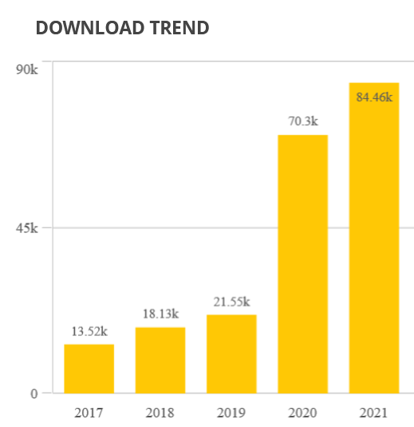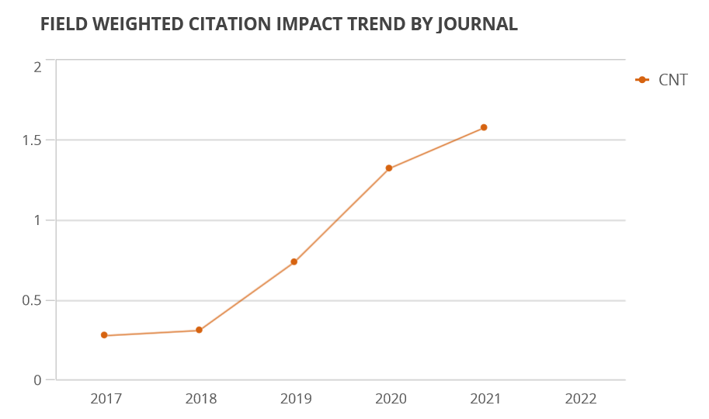
This is confirmed by the evolution of Centaurus’ CiteScore trend on Scopus.

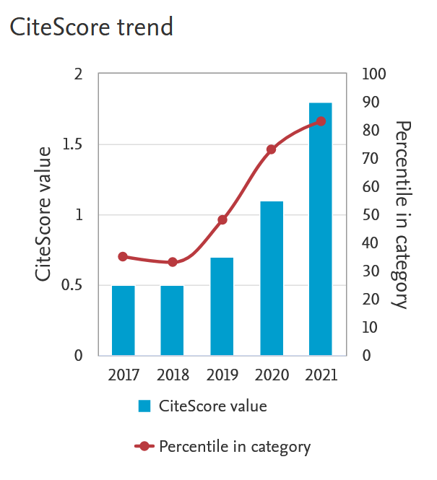
Centaurus is now listed as “the 1st out of 37 History of Science journals. This means the journal is among the top 3% in the sub-discipline of History of Science. This Journal is the 59th out of 2,527 History journals. This means the journal is among the top 3% in the discipline of History.”
Centaurus is the highest ranked “history of science” journal on Scopus for 2021 (not taking into account STS and Philosophy journals).
Our 2021 impact factor (IF = 1.198) is our highest ever and one of the highest in the field. (compare to some other generalist journals in the history of science: Isis = 0.514; BJHS = 1.245; History of science = 1.037; Annals of science = 0.343; Science in Context = 0.415)
Centaurus received for the first time a Q2 scimago score for History and Philosophy of Science
As metrics are always lagging, Centaurus should do even better in the coming years. Indeed, provisional data for 2022 show that our Scopus CiteScore improved another 30%. Furthermore, with Centaurus becoming Open Access, metrics may further improve, as studies suggest that publishing an article in Open Access may increase (even double) its impact and citation score.

Changing publisher
One of the challenges that we had not yet been able to solve in the 2018-2020 period was the increasing demand for equitable Open Access publishing. I had some difficult discussions with Wiley, but it was clear that there was no way forward to change Centaurus into an Open Access journal with them. We were also sensitive to the research community’s opposition against the big monopoly publishers, and the large profits they make (draining university and library budgets). Furthermore, the ESHS was not happy with the fact that Wiley fully owned the journal and that the society had no decision power on anything from appointing the Editor to the reference system used by the journal. As a result of all this, the ESHS presidents and I started renewed conversations with other publishers to see whether they would be interested in publishing Centaurus on different terms.
Because Wiley owned Centaurus, our only option was to start a new journal for the European Society for the History of Science. The plan was to create a new journal with the same scope and move with the whole editorial team and advisory board to the new journal (as Johan Rooryck has done, for instance, in 2015, by resigning from Elsevier journal Lingua and starting a new journal Glossa). While we were in advanced negotiations with Brepols to start a new journal for the European Society for the History of Science, Wiley decided that it would stop publishing Centaurus. Although they did not want to cede the rights to the journal (and the back issues), they graciously allowed us to continue to use the name Centaurus, which made it possible for us to assure continuity with the “old” Centaurus.
However, by the end of 2021 Wiley had received an offer for Centaurus, and just before we planned to publish the first issue of the new journal (also called “Centaurus”), Wiley sold the rights for continuing to publish “old” Centaurus to another publisher. As the “old” Centaurus had neither an editorial board nor manuscripts in the pipeline, this publisher started to contact colleagues to invite them to become editor of the journal, or submit a manuscript (many of you may have received such an email). Fortunately, our own Centaurus team was well prepared, with several journal issues in the pipeline, some of them building on previous work published in the “old” Centaurus. Furthermore, due to continuity in editorial policy, in the editorial team and in prospective contents, we had such a strong claim to be the real ‘successor’ of the “old” Centaurus. This led to assurances that we could be assigned the same ISSN number, virtually ascertaining the identity of the two journals, and be recognized by the ranking agencies. In the end, the other publisher realized that publishing a humanities journal like Centaurus is not viable without the full support of the community and they initiated contact to resolve the situation, which resulted in the ESHS and Brepols to jointly buy the rights to Centaurus. Ironically, this curious episode of the two competing Centauri made it possible for the journal to become truly part of, owned by and published for the history of science community. This means that, despite the stormy waters of the last year, Centaurus will continue as one and the same journal, building on a 70-year long tradition of publishing in the history of science.

“Diamond” Open Access
I am very pleased to let you know that Centaurus became a fully Diamond Open Access journal without any cost for either the author or the reader.
Diamond Open Access refers to a scholarly publication model in which journals and platforms do not charge fees to either authors or readers. Diamond Open Access journals usually represent community-driven, academic-led and -owned publishing initiatives. Diamond Open Access journals and platforms are equitable by nature and design.
Major changes in the academic publishing landscape (Plan S requirements, HorizonEurope mandates, the new obligation to publish in OA in the USA) make this a very important development for Centaurus and the field of history of science in general. Furthermore, as the mission of the ESHS and Centaurus are to foster collaboration in the history of science in Europe and beyond, it is crucial that colleagues in Europe and worldwide have access to our publications.
The biggest contrast is with gold OA, the model in which authors are requested to pay a fee (APC or “article processing charge”) to publish their article in Open Access. Although these fees are sometimes covered by national funding agencies, national grants are relatively rare in the humanities, and this leaves the majority of colleagues without the opportunity to publish their work in Open Access (or at a very high personal cost). This is why the ESHS and Centaurus have always rejected the gold Open Access route and resolutely choose for Diamond Open Access, which is free for authors as well as readers. Diamond Open Access is a major step to make Centaurus again a journal from and for the history of science community. As such, Centaurus contributes to building an alternative publishing culture based on the vision of science as a “commons” or as a “global public good”.
The diamond route we created also means that all authors will retain copyright of their article, which will be published under CC-BY license, and everyone can post and distribute the final published version wherever they want (own website, sharing platforms,…).
The cost of editing, copy-editing and publishing the journal needs to be covered, however. Centaurus’ Open Access will be financed initially by the ESHS and the new publisher, Brepols. During the first years, the journal will increasingly transition to a mixed financing model.
Typical revenue sources for Diamond Open Access are “grants, collectively-organised funding, donations, shared infrastructure, membership fees, freemium services, Subscribe to Open, etc.”
A key pillar of Centaurus’ funding model will be Subscribe-to-Open, an innovative model to publish scholarly journals in Open Access. The Subscribe-to-Open model uses traditional library subscription, so it is ideal to “flip” an existing subscription journal to Open Access. Instead of “closing off” the journal, so that only subscribers have access, the model uses the income from subscriptions to make the content freely available. Brepols favors this model as it can use its existing infrastructures and its relationships with libraries. (However, as we did not get access to Wiley’s subscribers, we cannot use existing subscriptions to transition to Open Access)
Subscribe-to-Open is a Coalition-S endorsed solution for sustainable and equitable Open Access publishing that provides an alternative to article processing charges (APCs), the mechanism used by most Open Access journals. It uses existing library relationships and subscriptions to convert gated journals to Open Access. Institutions simply subscribe or renew their subscriptions – there are no additional processes – and as long as subscription revenues are sustainable, the year’s issues are published Open Access.
In addition to the Subscribe-to-Open model, the ESHS will cover part of the cost of Centaurus (mainly based on its income through membership fees). We are currently also exploring the possibility for authors to donate APCs to Centaurus if they have them ready access to such publication funding (though Plan S and other means).
One other financing option is to apply for grants with funding agencies, philanthropic organizations etc. The disadvantage of such grants is that they are limited in time (e.g. 3 years) and thus not sustainable, while many small contributions by libraries and authors would be a more sustainable financing source.
It is important to realize that Centaurus may revert back to a normal (“gated”) subscription model or may have to downsize if we cannot find sustainable financing. This would be a loss-loss situation for everyone: libraries will have to pay much higher subscription rates to access articles in the future and many of our readers would lose access.
We therefore need the support of the history of science community to make Centaurus’ Open Access initiative sustainable. We kindly invite you to recommend Centaurus to your librarian by following this link: https://tinyurl.com/cntlibrarian. You will be invited to insert your librarian’s email address and you are of course free to modify the message itself.

Special published content 2020-2022
Special Issues
Between July 2020 and July 2022, we published 5 special issues on science diplomacy, representations of energy, verticality and the creative power of early modern experimentation.
The last call for Special Issues, sent in the summer of 2020 was again a great success. We received 15 excellent proposals, a small selection of which will be published by Centaurus from 2022 onward.
The evaluation committee, consisting of a team of eight colleagues (ESHS nominated members and Centaurus board members), reviewed the proposals and gave detailed feedback and recommendations on each of the proposals. This was a major effort for all involved but it was also extremely helpful for the guest editors, as this process allowed them to considerably improve their proposals! Many thanks to you all!
A new call for Special Issues will be circulated in September 2022. We hope for a similarly enthusiastic response from the ESHS community.

Spotlight Sections
Centaurus also publishes special sections, called Spotlight Sections or Spotlight Issues. A Spotlight section is a collection of short articles focusing on a specific theme, which can be a new subject, a neglected area, a theme of particular topicality, or a topic of specific relevance to the profession. Its aim is to jump-start new discussion and debate. The style of such an article is more concise and faster paced than individually submitted articles. Spotlight sections can either be commissioned by the Centaurus’ Editorial team or they can be proposed by scholars in writing to the Editor-in-Chief.
Centaurus issue, Volume 62, Issue 2 (May 2020) was a Spotlight Issue, which is available for free: Histories of epidemics in the time of COVID‐19. https://onlinelibrary.wiley.com/toc/16000498/2020/62/2.
In 2022, we published a follow-up Spotlight Issue on “How Epidemics End”, a timely historical reflection at a moment when everyone is wondering when covid19 will end. This issue is available in Open Access: https://www.brepolsonline.net/toc/cnt/2022/64/1
In 2021, we also published a short spotlight section on Silvanus P. Thompson: Quaker polymath and public scientist-engineer (guest editors are Stathis Arapostathis and Graeme Gooday)
Historiographical Section:
In accordance with our interest in the historiography of the sciences in Europe, we published a section of historiographical articles, “History of Science in Central and Eastern Europe”, guest edited by Mitchell G. Ash
Virtual Issues
Centaurus recently published its second Virtual Issue on “Historiographical reflections on sciences in Europe”, guest edited by Ana Simões and Maria Paula Diogo. Contributions of a historiographical bent have been a regular presence in Centaurus. However, from 2007 onwards when Centaurus became associated with the European Society for the History of Science, the number of papers and thematic issues choosing to tackle specifically historiographical reflections on sciences in Europe made their appearance. This virtual issue covering the 15 years of association of Centaurus, as published by Wiley, with the European Society for the History of Science, from 2007 to 2021. https://onlinelibrary.wiley.com/doi/toc/10.1111/(ISSN)1600-0498.Historiographical_reflections_on_sciences_in_Europe
Even a quick glance through the Centaurus archives reveals an incredible richness and variety of research. We hope that our Virtual Issue will inspire our readers to conduct their own impromptu journeys through the other articles in the Centaurus archives.
Note that because of the change of publisher, we will not be able to publish more virtual issues in the future.

ESHS contributions
Unfortunately, we did not receive any ESHS contributions (presidential lectures, prize lectures, young scholar lectures) in the period July 2020 - July 2022. It is our hope to publish such high quality contributions. [edit: we just received one ESHS contribution while finishing this report]
We did publish a short piece on “40 years of history of physics in Italy” submitted by SISFA, a new institutional member of the ESHS.

Submission and evaluation data
Since I started as editor, I made decisions on 575 manuscripts (original submissions and revisions)
The image below is a breakdown of the different kinds of submissions until the end of 2021:
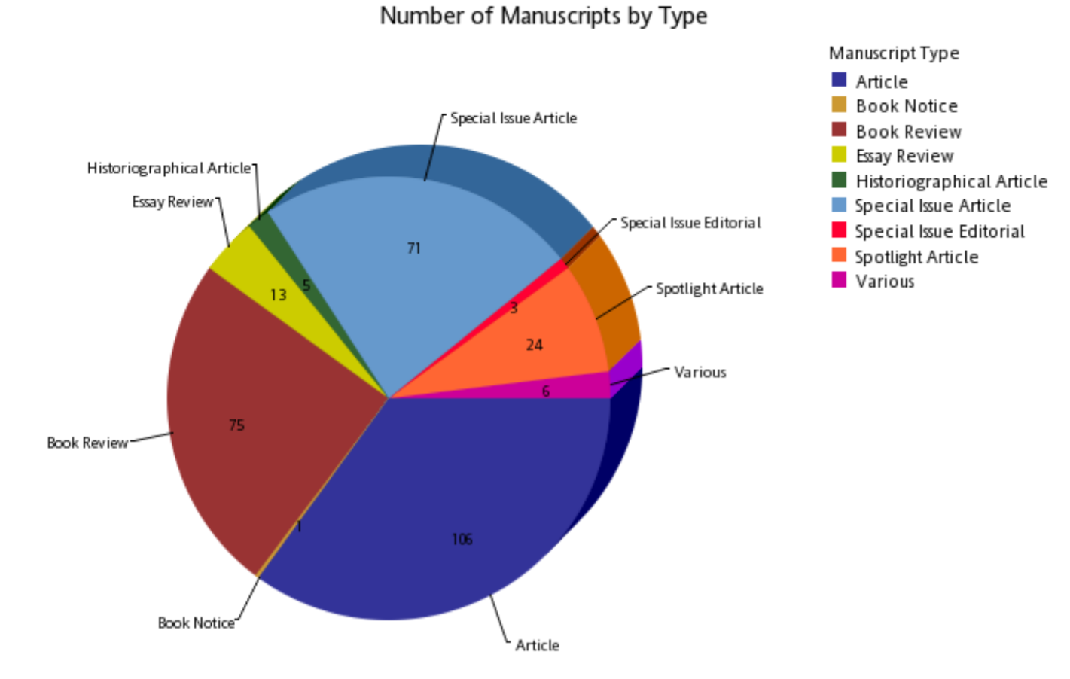
Because of the change of publisher and platforms, we don’t have good data on the period after December 2021, so the following are data based on the period since I started as Editor (June 2018) until the end of 2021.
We’ve received manuscript proposals from all over the world, from 41 countries, showing the wide appeal of Centaurus:
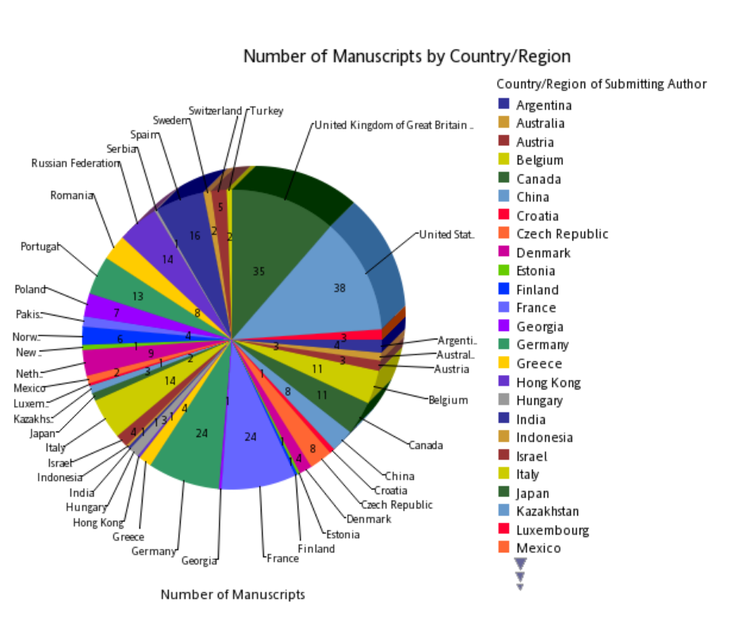

The decision rate for individual articles after first submission looks as follows:
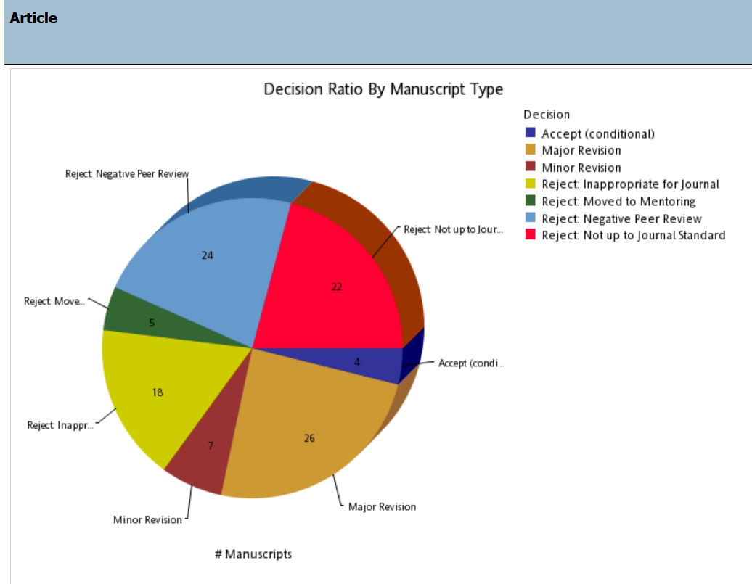

For special issue articles, this looks quite different:
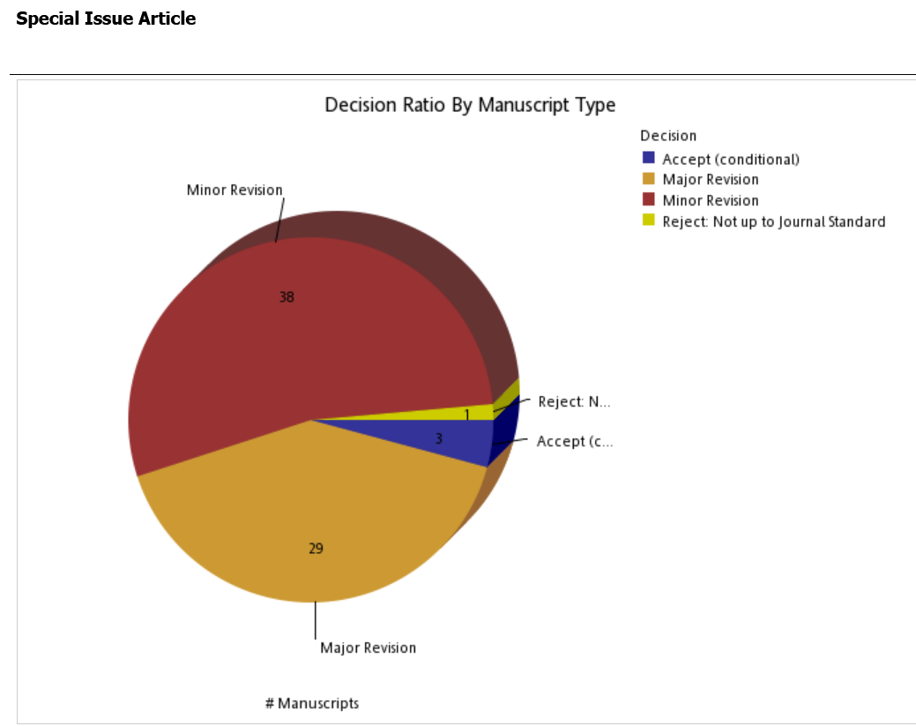
As special issue articles are invited and pre-selected contributions, it would be very unusual to receive a rejection at first submission. Note, however, that a rejection can still happen after a request for major revisions (around 10% of cases for special issue articles) if revisions were not successfully implemented.
This (still low) rejection rate for Special Issue articles is explained by the fact that Special Issue articles are curated: there is a strict selection process before submission. (1) by the guest editors (2) at the special issue level, there is a selection of the best special issues by the ESHS-Centaurus evaluation committee and (3) at the article level, by the evaluation committee (we recommend to drop or add specific articles that are part of the proposals). Furthermore, they have already been through a round of major revisions before being submitted to the journal. It is important to note that usually not all of the proposed articles are even submitted because of quality concerns or delays, and these articles do not show up in the statistics.

Timing of publication:
In July 2018, when I started as Editor, the journal was one year delayed with publishing its issues. Since May 2019, the editorial team was on schedule with submitting the manuscripts to Wiley’s production department. Because of delays at Wiley’s production department, we only started publishing on schedule by the summer of 2020.
Despite the major challenges posed by covid19 (authors, special issue editors and editorial team members got sick, were facing bereavement, had to find solutions for childcare, or even experienced long covid) we have continued to provide copy on schedule. We are dealing with a small delay in publication in 2022, due to legal and technical issues that accompanied the change of publisher. This is now sorted out and issue 3 will be published on schedule.

Mentoring program
As mentioned in the last report, we suggested that the ESHS Early Career Network take over the mentoring role, to avoid any conflict of interest in the editorial decision making. This has now been accomplished, and the Early Career Network is setting up the mentoring program, creating more integration between the ESHS and Centaurus.

Conclusion
Centaurus is flourishing, and published on time, thanks to a great editorial team, renewed interest from authors and guest editors, and a fantastic relationship with the ESHS and colleagues in the field more generally (including great reviewers!). It is an honor and a pleasure to edit the flagship journal of European Society for the History of Science.

6. The Secretary Report for the 2022 ESHS General Assembly (ST)

I was elected as ESHS secretary in 2018, at the General Assembly of the London conference, and re-elected for another term at the 2020 (online) Bologna conference. In the last four years, I thus contributed to the activities and initiatives of our society in the very difficult times defined by the pandemic (and the conflict in Ukraine more recently). I am confident that in my role I have helped the society to thrive.
Since 2018, I have been working towards ensuring that official communication could reach members more efficiently and effectively. I have thus been responsible for transferring all communications into a new mailing list so that it was possible for me to send routinely letter-headed emails to our members. I believe that thanks to this effort our members received information about the society’s activities more (and more rapidly and frequently). In leaving my current role, I am confident that the use of the mailing list tool will be considerably useful to my successor, especially as the number of ESHS members (and mailing list subscribers) has now grown to 586.
As ESHS secretary, I have also had important responsibilities. From December 2021, I took on the preparatory work for the 2022 Early Career Lectures. This comprised preparing the call for nominations for potential applicants, and arranging the Scientific Board ballot needed to vote members of a committee responsible for selecting Early Career Lecture scholars. I have also liaised with the members of this committee (Lino Camprubi, Julia Lajus, Gisela Mateo and Charles Wolfe). Their work has led to the selection of the three outstanding early career scholars presenting their work at the 2022 Brussels conference.
In February 2022, I was also responsible for advertising and collecting nominations for the 2022 Neuenschwander Prize and the Scientific Board ballots leading to awarding the 2022 prize to Professor Simon Shaffer. I also helped in the selection of panels for the ESHS Brussels conference.
From June I finally took responsibility for advertising and collecting applications for the Early Career Grants awarded by the society to allow early career scholars to attend the Brussels conference. I was also involved in the selection process and in communicating the results to applicants.
These activities added up to the routine secretarial work of addressing members’ queries, maintaining the membership records and registering new members (in collaboration with the treasurer) which I have carried out in the last four years. It has also entailed participating to council meetings, and at times take record of their outcomes.
What I have done could have certainly done better, but I wish to recall that the pandemic first, and the conflict in Ukraine after, have affected considerably what the ESHS and its Secretary could do in the last two years. This is especially the case in terms of actions supporting the growth of memberships. In my previous report (see http://www.eshs.org/wp-content/uploads/2022/03/2020eshs_general_assembly_-_minutes_of_meeting.pdf, pp. 37-39), I highlighted that ESHS membership has a somewhat unusual pattern of growth in that most members join the society for the biannual conferences. Only a sub-group of these members enrol beyond the two-years of automatic registration that the conferences grant. More could register in between our biannual meetings too.
In the 2020 report, I have also indicated some of the remedial actions needed to address this situation, especially in terms of:

- automatizing the membership registration process as something to be completed online via the website, without the input of the secretary and/or the treasurer

- if the registration process is made automatic, then the secretary would be in a position to send to all members whose membership is expiring an email reminding them to renew it, so that fewer members are lost at the end of the two-year period granted through attendance to biannual conferences.

It is vital for these improvements to secretarial tasks to take place that the website allows for automatic registration and payment. I believe that to achieve this goal, it is essential that an ESHS account be set up. Alternatively, online payment systems such as PayPal may also be considered as a viable option. I have to leave these important tasks to my successor as ESHS secretary!
I conclude this report by stating that I have learnt a lot in my four years role as the ESHS secretary and happily shared ideas, propositions, and discussion with colleagues that I truly enjoyed working with in the Scientific Council. One key example of this prolific exchange is that our society was among the firsts to mobilize in support of Ukrainian academics and express solidarity through a statement (http://www.eshs.org/2022/03/01/eshs-statement-on-ukraine-crisis/). I am glad and proud at the same time to have helped with its writing, and especially thankful to the scholars in Russia who supported us in the process.
I would like to thank in particular the three ESHS Presidents for helping me in my tasks and exchange ideas on various ordinary and extraordinary secretarial issues. Theo’s decision to host regular online meetings of the Scientific Council allowed us to share ideas more effectively, also helped also with community building. Koen Vermeir has taken on a mammoth task of transitioning Centaurus into open-access publishing. Roberto Lalli’s effort to increase the number of institutional members has been extremely successful. Liesbeth de Mol has so nicely restyled our website! Thanking them all, and everyone else in the Council, is my last act as ESHS Secretary!

Simone Turchetti (Manchester, 5.9.22)

7. ESHS Report of the Treasurer September 2018—September 2022 (EN)

Checking Account with Sparkasse Hochrhein (D)
Earnings
Total amount in the account at 13th Sept. 2018 Euro 24'475.73
Membership fees collected in 201 Euro 732.54
Institutional Membership fees collected in 2018 Euro 100.00
Membership fees transferred by Congress in London Euro 15'227.69
Membership fees collected 2019 Euro 415.00
Institutional Membership fees collected in 2019 Euro 100.00
Membership fees collected 2020 Euro 645.00
Institutional Membership fees collected in 2020 Euro 100.00
Membership fees transferred by Congress in Bologna Euro 16'260.00
Membership fees collected 2021 Euro 455.35
Institutional Membership fees collected in 2021 Euro 900.00
Membership fees collected 2022 Euro 360.00
Institutional Membership fees collected in 2022 Euro 1’000.00
Total earnings Euro 60'771.31

Expenses
15.09.2019 Reimbursement M.Husson for EC Conference Euro 1000 24.07.2020 Refund Matthieu Husson 576.60 Euro Euro 423.40
22.03.2021 Wiley, ESHS Member subscription –Centaurus Euro 1’820.00
30.10.2021 Hetzner Online GmbH, Server Hosting Euro 456.71
21.01.2022 Reimbursement for Liesbeth de Mol for renewal 5 years domain name to ESHS Gandi SAS Euro 93.96
07.02.2022 John Patrick Hajek for Centaurus, copy-editing Euro 650.53
15.03.2022 John Patrick Hajek for Centaurus, copy-editing Euro 1’016.56
31.05.2022 John Patrick Hajek for Centaurus, copy-editing Euro 646.80
22.06.2022 John Patrick Hajek for Centaurus, copy-editing Euro 496.19
02.09.2022 John Patrick Hajek for Centaurus, copy-editing Euro 1’341.36
Account fees, banking charges etc. Euro 666.46
Total expenses Euro 7'611.97

Total amount in the account at 3rd Sept. 2022 Euro 53'159.34

Sterling Account (GB) (established by Robert Fox)
The Sterling account, which was maintained by Robert Fox and Frank James, has been closed in 2020 with the approval of the General Assembly (cf. 2020 Minutes General Assembly, p. 39).

Zurich, September 3rd 2022 E. Neuenschwander

8. The PR-Officer Report to the ESHS General Assembly (RL)

As stated in my proposal two years ago, the main goal of my activity as PR-Officer of the ESHS has been to increase the number of institutional members of the ESHS. This goal has been achieved by contacting national and international scientific societies and institutions with a letter drafted and signed by the three presidents of the ESHS. While the institutional membership can certainly grow further in the future, the implemented action supported by the entire ESHS SB was quite successful. The ESHS had 3 institutional members when I became PR-Officer in 2020, while at the moment it has 13 institutional members as listed in http://www.eshs.org/members/. The growth of institutional members implied an increasing task for the ESHS PR-Officer, who has become the main contact of the ESHS with old and new institutional members for both administrative and scientific matters.

In preparation of the campaign for promoting the institutional membership of the ESHS, I have updated and extended a list of European institutions in the history of science that appeared in the old website of the ESHS. Recognizing the limit of the previous list, I had to create new categories to differentiate between different kinds of institutions. After consultation with the SB and following the suggestions of the presidents, institutions are now grouped in four categories:
- Extra-European Societies and Associations devoted to History of Science and cognate fields
- History of Science Societies in Europe
- Research institutions and centers
- History of science departments, programs and centers affiliated to European universities
I have then tried to fill the categories with as many institutions as I could, again with the support of the entire SB. While the list is certainly partial and incomplete and the categories might still be considered tentative, the final list is certainly much more extended and informative than the old one. The entire list can be found at the webpage of the new ESHS website: http://www.eshs.org/institutions/
Apart from that, I constantly participated to the online meetings of the ESHS board that occurred once every other month and addressed the various issues that have been addressed in the last two years, including the passage of Centaurus to full Open Access, the improvement of the communication channels, and the issue regarding the process for making the renovation of the membership easier to those who don’t attend the biennual conference. I participated constructively in these discussions providing my ideas and operationalizing what have been the final decisions.
I trust that the experience I gained in the last two years will be helpful in my possible future involvement in the society.
Roberto Lalli (Turin, 5/09/2022)

9. Web Editor and Communications Officer Report (BvT)

Web Editor and Communications Officer is an office that developed in 2020 from Newsletter Editor materializing the transition to a kaleidoscope of new tools of communication for and to ESHS members and our community at large. The use of these different communication channels is the result of a new constellation of ESHS offices/officers, and the active involvment of ECN members. The ESHS has the following media available

· FaceBook and Twitter accounts were opened and managed by ECN volunteers: M. Palma, A. Stöger, M. Ohnesorge
· Twitter and Facebook accounts for Centaurus (Koen Vermeir)
· New Website was designed by Liesbeth De Mol
· Members’ mailing list managed by Simone Turchetti
· Personal contact with the ESHS affiliates through Roberto Lalli
· ESHS Brussels 2022 faceBook and Twitter (and of course same for the next meeting)

Challenges ahead stem from this variety of channels of communication, and modes of distribution, which will require a broader communication strategy not only in the distribution of roles and responsibilities but also in the hierarchisation and priority in the dissemination of information. I’m really happy to leave the office in younger hands and keyboard, with a collegial group of colleagues who will remain or are stepping up in the different offices that pertain to communication. Out of personal experience, I would like to end with a cautionary remark: going forward, (co-)organizing the ESHS meeting should not fall to an active officer of the scientific board even if a close connection with the board is indispensable.

Brigitte Van Tiggelen, 5 September 2022

10. Webmaster Report (LdM)

When I became the new webmaster of ESHS our academic lives were still mostly organized on-line due to the pandemic. At that time, my view was that, instead of seeing only the negative sides of this situation, essentially waiting for it to just stop and go back to the old ways, we should try and see also the potential of organizing aspects of our academic lives on-line. I had quite some ideas when I was elected in that regard.
However, in order to implement such ideas, it is basic to have control not only over the content of the website but also over its structure and the way it is set-up. At the time, the website was set-up and controlled by and hosted at ENS in Paris. The people at ENS together with the previous webmaster, Mathieu Husson, did a great job at the time but because of the arrangements made with ENS, the webmaster could, essentially, only add content and new pages. Any other change always had to pass through the ENS using their Content Manager. This worked well several years ago but today it seems basic that the Society itself has more control over the site and so it was decided by the council to migrate the old site to another server and to give it a complete make-over. This then became my main task as the ESHS webmaster alongside the usual tasks. The new site was launched in early 2022.
The new website is now hosted on a virtual private server based in Germany with Hetzner – a provider that has a very good reputation in terms of security and privacy. It uses WordPress as a CMS (Content Management System). This is now a standard CMS used on many sites which should make it easy also for future webmasters to take over.
The new website now also has a more dedicated space to Centaurus. It is hoped that in the future we can develop this further amongst others by providing direct links to the journal’s published papers. Moreover, on the new site, the institutional members each have their own small page in which they can present themselves briefly.
I hope that the new site and its server can offer a strong basis to be used in the future to develop new on-line opportunities for the Society and its community.
Liesbeth De Mol, Gent, 27 July 2022

11. Archivist’s Report (EL)

My permanent academic affiliation is with the University of Turin in the Department of Philosophy and Education Sciences, where I am associate professor of History of Mathematics and History of Science. Habilitated as full professor of History of Mathematics (sector MAT04) and of History of Science (sector 11C2) in 2019, my research focuses on the dynamics of construction, transmission and socialization of tacit and explicit knowledge from international, national and local perspectives. The research ranges from the history of Italian ‘schools’ of mathematics, to the history of mathematics education, social and gender history. My interests are increasingly dedicated to the study of relationships between science and power, and in particular to the phenomenon of racial persecution and emigration of Italian mathematicians and scientists in the period 1938-1945. I authored and edited more than 100 publications, participated in national and international research projects and networks, and organized regularly meetings, both nationally and internationally.

In the last two years I had the pleasure to serve the ESHS as archivist (2020-2022). In this position, I had the opportunity to follow - and to some extent to contribute to - the efforts of the president and scientific board to highlight the Society’s identity. In particular I cooperated in rendering the ESHS website an even more efficient tool. Starting from the conviction that the conferences were perhaps the most important contribution that our Society has made to the history of science and that it be our duty to preserve their respective materials, I gathered their programs, books of abstracts, etc. All this material is now accessible on the website of the Society (http://www.eshs.org/archive-2/). Furthermore, the entire paper archive of the Society (7 folders of documents concerning the life and activity of the Society, including Statutes, statements about the changes in the Council, minutes of Council meetings, receipts, etc.) was digitized in order to ensure its conservation.

Serving the ESHS as Archivist is not only a stimulating intellectual adventure, but above all a way to continue to serve the ESHS and to support its on-going projects and research initiatives. Still much work is to be done. It would be important to complete (and to organize in a systematic way) the document and photo archives of our Society, both as far as the very beginnings of the ESHS and the first years of activity are concerned. I am an archive person. A significant part of my energy and scholarly work has focused on archival research: in this vein I am delighted to put my experience and interests at the service of the society and to work towards keeping the archives of the ESHS in good order. This task has however to be fulfilled in relation to all members of the Scientific Board, the actions of survey and conservation of archival sources being by their very nature a collective effort. Collaboration with the webmaster will be for example crucial in organizing, preserving, and providing access to information and materials in archives through digital forms. I thank you for your attention, and regard it an honour to be considered as a candidate for the position of Archivist.

Individual Members Reports

Daria Drozdova. During the last two years there were two principal projects in which I have been involved as a member of SB. First, to create an institutional link between ESHS and Russian Society for History and Philosophy of Science. Second, to prepare the proposal for ESHS 2024 conference which was planned to take place in Moscow. Due to current political circumstances the second project became unrealisable, and I cannot be optimistic that Moscow would be considered to be a good place for international gatherings at least for the next decade. However, the Russian Society for History and Philosophy of Science, as a non-governmental organization, is counting to keep being an institutional member of ESHS.

Matthieu Husson. I've been participating in the institutional life of the ESHS since 2014, first as webmaster. During the last mandate I served as a member of the scientific board. In this respect I've helped with the evaluation of proposal for the ESHS conference and also followed different questions of the life of the society in which I was involved from previous mandates: early career network activities (until 2021, when the early career network elected its own representatives during their conference in Athens), mentoring initiative, a few administrative issues linked to the legal status of our society with French authorities. I also participated regularly in the board meeting of the ESHS, especially at the "in between" meeting organised in Athens in 2021.

Pietro Daniel Omodeo. As a member of the Scientific Board of the European Society of the History of Science, I attended the regular meetings and accompanied the board decisions. I was especially involved in assisting the organization process of the annual meeting of the Society, the Bruxelles conference of September 2022. In this context, I evaluated panels and papers submissions. I wish I can continue serving the Society and be actively contribute to its intellectual life and practical challenges.

Giulia Rispoli. As a member of the ESHS, my work over the past two years has been directed toward developing innovative transdisciplinary research within the domain of Anthropocene studies as an area that connects historical and epistemological investigation and the natural sciences to address the role of humanity as an agent of planetary transformation. In the framework of this research, I sought to strengthen collaboration between members of the scientific board of the ESHS, the Max Planck Institute for the History of Science (Dep. 1) and the community of geo- and Earth scientists, laying the ground for further projects and initiatives.
In particular, as a former Max Plank Research (currently visiting scholar at the Dep. 1 until 2026) where I was a core member of the Anthropocene Formations research group, my recent collaboration with the Anthropocene Working Group (AWG) and the Haus der Kulturen der Welt (HKW) offered an unprecedented occasion for more than 60 specialists from the Earth and atmospheric sciences, nuclear physics, history of science and technology, anthropology, cultural studies, etc. to discuss and provide an historical account of the diverse cultural, intellectual, epistemic, social, economic, and political drivers that led, in a systemic fashion, to the production, distribution, and accumulation of the main material markers that signal the emergence of the Anthropocene as new geological epoch. This effort resulted in the large multimedia publication Anthropogenic Markers: Stratigraphy and Context, which features contributions from outstanding historians of science including numerous members of the ESHS (among the participants in the project, Jürgen Renn, Maria Rentetzi, Soraya Boudia, Nestor Herran, Xavier Roqué, Angela Creager, Kate Brown, Pietro Daniel Omodeo and many others). The project has indeed already led to spin off initiatives, among them the series of conferences “Markers: Material Delineation of the Present” and “Unearthing the Present”.
Over the past two years I have also collaborated with the Secretary of the ESHS, Simone Turchetti and other scholars who are part of the Commission of Science, Technology and Diplomacy headed by Turchetti, such as Officer Roberto Lalli, Doubravka Olšáková and Gordon Barrett. With Turchetti in particular, I worked on the co-production, as co-editors, of a Special Issue that examines the growing interest in science diplomacy and the parallel lack of in-depth historical studies on this new concept (Science Diplomacy, HSNS, 2020)
Moreover, in the past two years, I worked towards organizing a workshop funded by the Max Planck Society that involves scholars of the MPIWG and the CIUHCT, Centro Interuniversitário de História das Ciencias e da Tecnologia (CIUHCT) to kick-off long-term cooperation between the German and the Portuguese institutions. I led this initiative from the beginning with members of the scientific board Maria Paula Diogo and Ana Simoes. However, I had to hand this task over to other MPIWG colleagues (Helge Wendt and Mona Friedrich) as I moved to a new position as an Assistant Professor at the University of Venice. However, I plan to participate in the forthcoming workshop and all the further initiatives that will emerge from it.

12. President-elect report and Plan of Action, 2020-2022 (DJ)

The years 2020-2022 were difficult years for the whole academic world. The pandemics has modified our professional life, the way we meet and relate to each other and to our work. Then, the war has teared us further apart, destroying professional collaborations, making libraries and archives inaccessible, dividing further the academic world. In these times, professional societies face complex challenges. But they are also needed more than ever. These two years when I was part of the joint presidency of the ESHS have taught me a lot and I hope this knowledge will bear fruits in the years to come. The good part of our new lives lies in the possibility of organizing online meetings with relative ease and speed, and increased efficiency. In the past two years we had frequent online meetings to discuss the challenges the ESHS was facing, to solve some of them, and also to mark some of our successes. The three presidents of the society were meeting frequently with officers from the Scientific Board, with the editor in chief of the Centaurus; we also had frequent board meetings. For me, these were also learning opportunities, and I would like to thank both Ana Simoes and Theodore Arabatzis from whom I am continuously learning the ways of good governance and crisis management. I think that all in all the ESHS has faced successfully the crisis of the pandemic. We have a new web-site (due to our excellent web-master) which, for the first time, is owned by the society. Centaurus has become fully open-access, and is now published in collaboration with Brepols and co-owned by the society. In addition, due to the excellent work of Koen Vermeir and his team, Centaurus is scoring very high in the rankings. It is worth mentioning that we have managed to achieve this despite numerous adversities, twists and turns of a difficult relationship of collaboration with Wiley and unexpected surprises. We have still not solved some of the pending problems regarding having our own official bank account and a system of online payment of membership; once this would be done, I am confident we will see also an increase in membership and funds. We can use the new web-site to move to a next level of the online collaboration, something I wanted very much to do in the past year, namely a series of online scientific meetings and talks with the ESHS stamp on them, and the youtube channel of the society.
The plan to organize the 2024 conference in Russia fell to the ground. But we have managed to keep up the ties with some of our Russian colleagues – who need all the encouragement we can provide, because simply being members of ESHS and members of the Scientific Board can place them in a difficult position in their own country. I think it would be important for the ESHS to keep up ties with both Russian and Ukrainian colleagues. Organizing online talks and meetings, recording them and broadcasting them on youtube can contribute to providing support for colleagues in these countries. And perhaps not only them. Taking into consideration the economic crisis and the explosion of costs of living and travel, in-person meetings and resources are becoming more costly, sometimes unaffordable. Therefore, this is the direction in which I suggest we move for the next two years.

Statement of candidacy to the presidency of the ESHS
After two years as president-elect of the ESHS I am hereby posing my candidacy for the presidency of the ESHS, hoping to put to use what I have learned so far. We are facing times of crisis and considerable challenges to the academic life. In fact, it is my belief that academic life as we knew it is largely over; that post-pandemic and post-war times will transform our universities and our lives as researchers in ways which are difficult to foresee and we still need to comprehend. It is my belief that professional societies need to be more present in our increasingly isolated academic lives, but perhaps need to be present in a different way than before. The tradition in the past decades was that academic societies were organizing conferences and subsidizing a journal; and the life of the society was very much concentrated on these two institutions. This has partly changed during the pandemic, with many groups organizing online meetings, conferences and seminars. It has been my suggestion, two years ago, that ESHS moves in this direction, establishing a youtube channel where we can upload recordings of talks, but where we can also broadcast live talks and meetings. Such a channel can be a repository of reference materials for many colleagues across the world, but also a meeting point for those interested in history and philosophy of science and, ultimately, a channel of recruitment of new members. The challenges we faced in the past two years did not leave us with sufficient time and energy to pursue this plan. Maybe in the academic year 2022-2023 we can make the establishment of a series of talks oriented towards a larger audience and broadcasted on our own youtube channel, our priority. In parallel, we can develop on our web-site a repository of online materials and links to what is going on in the profession. We can make the web-site of ESHS and the youtube channel a development-hub for our profession which, together with the open-access Centaurus would move ESHS into a different dimension, into providing reference material, content, spreading news about the profession across our currently divided world. Personally, I think that such a substantial online presence will give us strength and courage to go through the current crisis. I am not arguing in favor of moving completely online. In person meetings are important and necessary. But they will become increasingly costly – and the costs will be prohibitive for many of our colleagues. I think it is important to respond with establishing our online presence, and making online meetings, talks, and other resources as widely available as possible.
In the same spirit of full open access, I would suggest that once we establish a repository of such video-materials, we add to it some of the courses we are teaching in our different institutions and universities, making them available to students everywhere. I refer especially to entry-level courses, designed to attract students to our profession. I envisage this as a new, faster way of establishing de facto collaborations across borders, in ways which can be further institutionalized, if (when) needed.

Dana Jalobeanu

13. Presentation of the candidates for the new Scientific Board

The ESHS Scientific Council (Officers) proposal for the new Scientific Board is the following:

Council Members
- President Elect: Simone Turchetti – He has accepted to be nominated.
- Secretary: Roberto Lalli – He has accepted to be nominated.
- Treasurer: Erwin Neuenschwander – The Treasurer may be re-elected an unlimited number of times. Erwin is willing to serve for one more term.
- Webmaster: Liesbeth de Mol – Liesbeth is willing to serve for one more term.
- Web Editor and Communications Officer : Laura Georgescu – She has accepted to be nominated.
- Archivist : Erika Luciano – Erika is willing to serve for one more term.
- Public Relations Officer: Hugo Soares – He has accepted to be nominated.
- Centaurus Editor-in-Chief: Koen Vermeir – This position is not up for election.

Individual Members
- Dimitri Bayuk (Russia) – He has accepted to be nominated.
- Matthieu Husson (France) – Matthieu is willing to serve for one more term.
- Pietro Omodeo (Italy) – Pietro is willing to serve for one more term.
- Giulia Rispoli (Germany & Italy) – Giulia is willing to serve for one more term.

Institutional Members

The following scholars have been nominated by their institutions (four will be voted by the General Assembly):

- Catalan Society for the History of Science and Technology – Josep Simon (he is willing to serve for one more term)
- Center for the History of Science and Technology, Lisbon – Ana Simões
- Institute d'Història de la Ciència in Barcelona – Gemma Cirac-Claveras
- Max Planck Institute for the History of Science – Alfred Freeborn
- Science History Institute – Brigitte van Tiggelen

Please Note that no other candidacy proposal has reached the ESHS Secretary, hence all the standing candidates are the candidates nominated by the Scientific Council.

- President Elect

Simone Turchetti is a senior lecturer at the Centre for the History of Science Technology and Medicine (CHSTM) of the University of Manchester (UK, Britain). In 1999, he moved from Italy to Britain to start a Master (and then a PhD) at the CHSTM. Since then, he has worked in various other universities (University of Bristol, University of Leeds) before returning in 2009 at the CHSTM after he was awarded an ERC Starting Grant on the five-year project The Earth Under Surveillance (TEUS - http://teus.unistra.fr/). He has since been involved in other collaborative projects, including the H2020 InsSciDE (https://www.insscide.eu/). He is also the president of the DHST Historical Commission on Science, Technology and Diplomacy (STAND - https://sciencediplomacyhistory.org/), and he was the ESHS Secretary between 2018 and 2022. In 2021, he won an ERC Advanced Grant for Neworld@a, a new project on the diplomacy of scientific data (codata.org/initiatives/data-policy/neworlda-project/).
Simone is interested in the history of 20th century science, with the focus on the impacts of scientific exchanges and collaborations on international relations. He has written two monographs (The Pontecorvo Affair, Greening the Alliance), edited two essay collections (The Surveillance Imperative, Science Studies during the Cold War) and contributed to several journal special issues and articles.

Statement
It would be a pleasure and an honour for me to become the next President Elect and I am thankful to the ESHS Scientific Council for considering nominating me for this very important role in the life and growth of our society.
While at a still relatively early stage in my academic career, I think I have what is needed to help the society in growing further, and be part of the system of Presidents’ rotations and collaborations that are distinctive of the management of ESHS business. I have experience of collaborative work and management of organizations active in our field, as proven by my role in the establishment and development of the STAND commission (see profile below). I have taken these collaborations beyond the history of science domain in the context of H2020 research initiatives such as InsSciDE. I have been successful in obtaining funding for history of science research as I was awarded both European Research Council (ERC) Starting and Advanced grants. I have contributed to the writing of monographs, edited collections, special journal issues and articles in international journals in our field and beyond.
Above all, in terms of both research interests and career, I am an international scholar who strongly believes in sharing ideas across borders and overcoming nation-centric (and Euro-centric) views. I am Italian by birth, but I have completed postgraduate studies in the UK, where I have worked ever since. Over these twenty years of scholarly activities, I have established working partnerships with colleagues in various continents, and especially with European scholars, both in the context of the ERC projects and other collaborative initiatives.
In 2017 I have offered to help the ESHS, as I felt that promoting our society was one way to countering the resurgence of divisive approaches in Europe (with Brexit looming large) and encourage cross-country exchanges in our field, thus giving voice to a much wider plurality of voices. On that occasion, I felt that it was important for me to write to the then ESHS President Karine Chemla indicating that I wished to help. I am glad since then to have crossed path with ESHS Presidents like Ana Simões and Theodore Arabatzis who shared ambitions similar to mine in propelling geographical, gender and disciplinary diversity within the society. It is with the same spirit that I would approach my new role as President Elect.
Importantly since 2018, I have also been the ESHS secretary. This role has given me an intimate knowledge of the society’s inner workings, activities, and issues to address. In that respect, I am already familiar with the current members of the Scientific Council, and have already established a working relationship with them. In my role as secretary, I have also familiarized with the society’s procedures and statutes. I would thus be able to identify key areas for potential development, and activities that we may carry out more effectively. I could thus further advance some of these plans in my role as President Elect. Of course, it is a tradition of our society’s own activities that President Elects typically use their term to learn what the role of President entails, especially by looking at what the President and the Vice-President do. I would thus follow closely what the incoming President Dana Jalobeanu, and the incoming Vice-President Theodore Arabatzis, will propose.
However, in this statement, I also identify some of the issues that, if elected, I would like to work on, especially if there is consensus that tackling them may be beneficial to the society:

- Account/automatic membership registration. My experience as a secretary (as indicated in the 2022 statement) shows that one of the issues the society should immediately address is how to retain those members that automatically leave the society by not renewing their memberships at the end of the automatic registration granted through participating to biannual conferences. I wish to work with the new secretary towards ensuring that a new online registration system is in place (also in connection with a new ESHS bank account).

- Relationship with institutional members/societies. At a more substantial level, I would like to introduce initiatives enabling the ESHS to strengthen its ties with other history of science societies across Europe. In the last two years, our PR officer Roberto Lalli has done an admirable work in taking some of these societies in the ESHS as institutional members. The ESHS should build further on this success by establishing a forum in which to take the dialogue with European history of science societies to a programmatic level, establish ways in which to collaborate more, and join forces in initiatives that may be mutually beneficial. The ESHS is now succeeding more in encouraging cross-country exchanges between historians of science. It should do the same for history of science societies.

- In-between meetings. The action above may also lead to re-configuring the ESHS in-between meetings as opportunities to consolidate the relationship between the ESHS and other European history of science societies. It is my view that while these meetings are useful, they could offer more in terms of participation and ambition. While the procedural aspects of this proposal would need to be considered upon by the Scientific Council, I believe that strengthening these relationships would be one important way to build on the society’s past efforts to promote exchanges across and beyond Europe (as noted in Ana Simões’ statement for the 2022 ESHS General Assembly).

While working on these issues, I would make myself available for anything else helping the ESHS to develop further, in the understanding that, as indicated earlier, I trust the society to be a powerful instrument in bringing about change in Europe, especially by stimulating interactions displaying the merit of enhancing further cultural exchanges across and beyond the continent.
Simone Turchetti (Manchester, 5/9/22)

- Secretary

Roberto Lalli is Assistant Professor in the History of Science and Technology at the Politecnico di Torino. His research focuses on the interaction of epistemic, political and social factors the history of twentieth-century physics. After receiving a PhD in International History in 2011 at the University of Milan he was Postdoctoral Fellow in the History of Modern Physical Sciences at the MIT’s Program in Science, Technology and Society (2011-2013) and, subsequently, a long-term Research Scholar at the Max Planck Institute for the History of Science in Berlin from 2013 to 2022. In addition, he has been Visiting Scholar in the Research Program on the History of the Max Planck Society, and Visiting Lecturer at the Technische Univesität Berlin and University of Turin. He has received fellowships and research grants from various institutions, including the Center for History of Physics, CalTech, University of Milan and the Van Leer Jerusalem Institute. He has organized numerous scholarly meetings and received about forty invitations to present his research in international conferences and seminars including that as plenary speaker at the III International Conference on History of Physics in 2018. Roberto Lalli is an active member in various committees and societies. Among his activities, he is PR-Officer of the ESHS, is a member of the History of Physics Group of the European Physical Society and of the DHST Commission for Science, Technology, and Diplomacy, as well as of the Executive Board of the Italian Society for the History of Physics and Astronomy (SISFA).
He has published extensively on various topics in the history of modern physics, scientific publishing, and science diplomacy. His papers have been published in peer-reviewed journals such as Annals of Science, Centaurus, HSNS, Isis, Notes and Records, Scientometrics, Annalen der Physik, Nature Astronomy, and Nature Reviews Physics. His first monograph (Springer 2017) offers a new perspective on the issue of science diplomacy through the history of the international community of scientists working on general relativity during the Cold War. He has also co-edited the volume The Renaissance of General Relativity in Context in the Einstein Studies series and two special issues: “The Renaissance of Einstein’s Theory of Gravitation” of the European Physical Journal H,” and the Centaurus special issue titled Global Perspectives on Science Diplomacy.

Statement
I am extremely honored to be nominated as Secretary of the European Society for the History of Science. Building on the successful activities of the previous secretaries and on my own experience as PR-Officer of the ESHS, if elected I will fully support the Presidents in the many challenges the society will have to face. In particular, I will continue and extend the system of internal communication through a mailing list for members that have been set up by the current secretary. In coordination with the other members of the SB, I will strive to improve communication and coordination of the activities in the history of science within Europe and more globally so that the ESHS increases its role as an arena for extensive information sharing and discussion on such activities. One main task I am willing to pursue is to ameliorate (together with the treasurer) the process of membership fee payment, which is at the moment not feasible through the website.

In the past two years, the ESHS underwent important changes, including the building and launching of a new website, the change of publisher and the passage to Open Access of the journal of the society Centaurus, the growth of institutional membership, among others. I tried to do my best as PR-Officer and member of the SB of the ESHS to support all these major transformations. If elected, the major work will be to provide a continuity with the great work that has been done in the recent past and try to make some processes, especially concerning communication and payment of membership, more efficient and rapid. Along the same line, in cooperation with the new PR-Officer and the Presidents I would like to use my role to build a stronger role for the ESHS as a central node in the network of societies and institutions in Europe and beyond, especially with more programmatic actions with the greater pool of institutional members the ESHS has now built.

Finally, I look forward to being available to individual members for any ideas, questions, concerns, or doubts that might want to share concerning the ESHS and its future and being the personal link between the ESHS SB and all members. I have been active in a number of committees, organizations, and societies, and I consider a fundamental part of my scholarly activity to work for them to organizationally support their daily operations and future plans.

Roberto Lalli (Turin, 5/9/2022)

- Webmaster

Liesbeth De Mol, art historian and philosopher, focuses her research on the history and epistemology of computing and programming, driven by the conviction that it is a fundamental task to engage with modern technique in order to see the variety of epistemological obstacles that surround it and need to be overcome if one wants to go against more ideological views on technology. She has worked on the history and philosophy of computability; the reciprocal histories between mathematics, computing and engineering as well as the historical and epistemological connections, or lack thereof, between logic and computer science. Besides she has been working on a more philosophical question related to human-computer interactions. Lately she has shifted her attention to the epistemology of programming. She has published in a variety of venues which reflect her interdisciplinary stance. She is also the founding president of the DHST/DLMPST commission for the history and philosophy of computing (www.hapoc.org) and, currently, also the PI for the ANR research project PROGRAMme on the history and philosophy of computer programs, (https://programme.hypotheses.org/). In 2021 she became the secretary-general of the IUHPST/DHST. In 2020 she was awarded a bronze medal by the CNRS.

Statement
It is my pleasure to present my candidacy for a second term as the webmaster of ESHS from 2022 to 2024. During my first term, the old website, which was kindly hosted at ENS, Paris, was migrated to another server based in Europe and given a complete make-over (see my report). This provides a strong basis to develop new possibilities for the on-line presence of the Society. Amongst others, I would like to come back to my earlier promise of extending the current mentoring program that is set-up at Centaurus by providing a platform through which senior researchers can be contacted as possible mentors for early career scholars. I see my role of webmaster mostly as one where I can assist and help others at ESHS to develop their on-line activities and so welcome any further ideas for helping the community with organizing their on-line lives.

- Communication Officer

Laura Georgescu is an Assistant Professor in the Department of History of Philosophy, Faculty of Philosophy at the University of Groningen. She specialises in the history and philosophy of early modern natural philosophy. Her research interests concern questions about the struggles early modern natural philosophers encountered in their attempt to articulate new scientific concepts, and the various constraints at play in this process. Her doctoral research focused on questions in the context of early modern non-mechanical theories of magnetism, with a particular focus on the role that empirical practices played in such conceptual articulations. Her current research addresses the extent to which commitments to various principles of natural philosophy constrain the articulation of empirical concepts. She recently co-edited the first collected volume on the natural philosophy of Kenelm Digby (Springer, 2022).

Statement
I am extremely honoured to be nominated for the position of Web Editor and Communications Officer of the European Society for History of Science. I hope that my current function as the coordinator of the Groningen Centre for Medieval and Early Modern Thought (GCMEMT) and of its associated blog, mailing list, social media, and YouTube channel, as well as my experience as the main organiser of the Dutch Seminar in Early Modern Philosophy (DSEMP) for the last three editions, will help me carry out the tasks associated with this position successfully. If I get elected, by closely working together with the PR officer and the Webmaster, I will do my best to help the members of the ESHS community stay connected, and to facilitate the communication of the ESHS’s vision, opportunities, and results, both within and beyond the membership of the society. The ESHS website, mailing list and Twitter account already function as wonderful platforms to facilitate the dissemination of relevant information amongst the community members, and I would aim to maintain their activity, and expand their audience. The future of the ESHS depends on retaining and constantly renewing a strong network of early-career researchers. In order to do so, the ESHS has created some wonderful projects over the last few years, such as the Centaurus Mentoring Program and the Early Career Plenary Lectures, and I would aim to ensure that both the members of the ESHS and the wider public are informed about the achievements and goals of such projects. To this end, I would want to be actively involved in creating and collecting relevant content targeting these specific projects by actively involving the existing members of the network (e.g. conducting interviews with the members, asking the members to create content for future members, creating online surveys to improve the projects etc), as well as creating an ESHS YouTube channel to disseminate the lectures more widely, and to stimulate young researchers to actively participate in the growing ESHS community.

- Archivist

Erika Luciano. My permanent academic affiliation is with the University of Turin in the Department of Philosophy and Education Sciences, where I am associate professor of History of Mathematics and History of Science. Habilitated as full professor of History of Mathematics (sector MAT04) and of History of Science (sector 11C2) in 2019, my research focuses on the dynamics of construction, transmission and socialization of tacit and explicit knowledge from international, national and local perspectives. The research ranges from the history of Italian ‘schools’ of mathematics, to the history of mathematics education, social and gender history. My interests are increasingly dedicated to the study of relationships between science and power, and in particular to the phenomenon of racial persecution and emigration of Italian mathematicians and scientists in the period 1938-1945. I authored and edited more than 100 publications, participated in national and international research projects and networks, and organized regularly meetings, both nationally and internationally.

Statement
In the last two years I had the pleasure to serve the ESHS as archivist (2020-2022). In this position, I had the opportunity to follow - and to some extent to contribute to - the efforts of the president and scientific board to highlight the Society’s identity. In particular I cooperated in rendering the ESHS website an even more efficient tool. Starting from the conviction that the conferences were perhaps the most important contribution that our Society has made to the history of science and that it be our duty to preserve their respective materials, I gathered their programs, books of abstracts, etc. All this material is now accessible on the website of the Society (http://www.eshs.org/archive-2/). Furthermore, the entire paper archive of the Society (7 folders of documents concerning the life and activity of the Society, including Statutes, statements about the changes in the Council, minutes of Council meetings, receipts, etc.) was digitized in order to ensure its conservation.

Serving the ESHS as Archivist is not only a stimulating intellectual adventure, but above all a way to continue to serve the ESHS and to support its on-going projects and research initiatives. Still much work is to be done. It would be important to complete (and to organize in a systematic way) the document and photo archives of our Society, both as far as the very beginnings of the ESHS and the first years of activity are concerned. I am an archive person. A significant part of my energy and scholarly work has focused on archival research: in this vein I am delighted to put my experience and interests at the service of the society and to work towards keeping the archives of the ESHS in good order. This task has however to be fulfilled in relation to all members of the Scientific Board, the actions of survey and conservation of archival sources being by their very nature a collective effort. Collaboration with the webmaster will be for example crucial in organizing, preserving, and providing access to information and materials in archives through digital forms. I thank you for your attention, and regard it an honour to be considered as a candidate for the position of Archivist.

- PR Officer

Hugo Soares is an early career scholar who received his PhD in History, Philosophy and Heritage of Science and Technology in 2021 at the NOVA School of Science and Technology. He is currently Postdoctoral Fellow at “E3GLOBAL – Einstein, Eddington and the Eclipse. A global history of the total solar eclipse of 1919”, hosted at the Interuniversity Centre for the History of Science and Technology (CIUHCT). His doctoral thesis focused on the role of the National Institute for Scientific Research (1974-1992), the governmental institution that managed and financed university research during the transition from the Estado Novo dictatorship (1933-1974) to the democratic period. Besides his interest in the development of the Portuguese scientific system, and current activity related to the history of astronomy and physics in the twentieth century, he is also interested in environmental history, namely in the study of the occurrence of big wildfires under the lens of the Slow Disaster and the Anthropocene, Material Culture and the intersection between photography, film, science, and history of science, as well as the potential of film as an academic output. He is an integrated member of CIUHCT and a member of the Scientific Board of the Observatory for the Anthropocene. Outside the academia, he was also president of Oficina do Cego, a non-profit structure dedicated to preservation of traditional printing knowledge, techniques and equipment and is currently part of Royal_Cine, a project sponsored by the Lisbon municipality dedicated to social intervention through film.

Statement
Dear colleagues and friends, it is a great honour to be nominated for Public Relations Officer of the ESHS. Having recently finished my PhD and having started a new research endeavour for the next few years, I feel I have conditions to give back to the community and contribute to its growth.

My main concern will be giving continuity to the core task of this office, fomenting the relationship between the ESHS and its counterparts on the national, regional, and international level and contribute for a greater visibility of the society.
It is also my intention to, at the very least, launch an internal discussion about the establishment of more connections between the ESHS and non-academic institutions. It seems clear that there is an unfulfilled role for historians in the current state of the world. Even more for historians of science, as the alarming succession of international and global crises we are witnessing share a backdrop of scientific and technological nature that doesn’t seem to be properly acknowledged and considered for decision making. This objective is certainly connected with the Open Science movement, already implemented in Centaurus with great success, but should expand to other instances such as European political institutions and media outlets, as well as the society’s own channels of communication.

I would finally like to acknowledge that, as an early career scholar (albeit not a young one!), I naturally do not share the same level of experience as my predecessors, both at the scientific and institutional level. Therefore, I will be counting on their expertise as well as the support of the other officers and board members to help me contribute to the development of the ESHS in the best way possible. I end my statement by praising the society’s efforts regarding the role of the early career members, this will certainly be reflected in vigorous new generation of historians of science.

Individual Members

- Dimitri Bayuk

After graduating from the department of physics at Moscow University and five very important years as a mathematician in the Keldysh Institute for applied mathematics, I switched to the history of science and in 1992 defended my PhD thesis on Galilean mechanics. For more than 30 years I worked as a researcher in the Vavilov Institute for History of Science and Technology, and more than 20 years as an editor of the associated journal. All this time I tried to develop international cooperation of scholars, and participated in organization of many international projects and meetings together with famous foundations and institutions, such as La Maison des sciences de l’homme (France); Fulbright Foundation (USA); Leibniz Gesellschaft (Germany); National Tsing-Hua University (Taiwan). In 2012 I was elected a correspondent member of the International Academy of the History of Science and in 2018 I was elected an effective member of this Academy. The recent political challenges changed my research agenda, and I am currently working on a new project devoted to the history of empires and the function of science, especially astronomy and mathematics, in building and dismounting empires and neo-imperialist states. I am firmly committed to the development of international scientific communication, looking for ways to invite representatives of the communities isolated from the international because of aggressive and totalitarian tendencies in the politics of their countries.

- Matthieu Husson

It would be an honor for me to serve a second and final mandate as a member of the scientific board of the society and help with whatever questions or tasks the incoming board of officers would see appropriate. In this mandate, if granted to me, I would continue to have a special concern for the early career colleagues and to foster the mentoring initiative. Open sciences issues in which our society is also very active, especially in connection to Centaurus, are also important for our community and I'm also willing to be useful if possible in this area.

- Pietro Omodeo

Pietro Daniel Omodeo is a cultural historian of science and a professor of historical epistemology at Ca’ Foscari University of Venice (Italy). He received his Ph.D. degree in philosophy from the University of Turin (Italy) in 2008. From 2010 to 2017, he was a research scholar at the Max Planck Institute for the History of Science in Berlin (Germany), and from 2012 to 2017 he was a member of the Collaborative Research Centre Episteme in Motion (Freie Universität of Berlin). In 2016, he was awarded an ERC Consolidator Grant for the project ‘Institutions and Metaphysics of Cosmology in the Epistemic Networks of Seventeenth-Century Europe’. Since 2020, he has been the Principal Investigator of a project on the history of the geological transformations of the lagoon of Venice in early Modernity, ‘Positioned Cosmology in Early Modernity: The Geo-Praxis of Water-and-Land Management in Venice’, funded by the Italian Ministry of University and Research. Since July 2021, he has been in charge of a Max Planck Partner Group on Anthropocene Venice. He is chief editor of two open-access series resulting from a collaboration with Edition Open Access of the Max Planck Society: Knowledge Hegemonies in the Early Modern World (printed by Edizioni Ca’ Foscari) and Verum Factum: Studies and Sources on Political Epistemology (to be launched soon). Omodeo is a member of the scientific board of the European Society for the History of Science (since September 2020). He has taught classes in environmental philosophy in Venice in Environmental Humanities and in the Venice-Bologna HPS Master.

Statement
I would be honored to continue serving the SB of the ESHS and to contribute to its scientific and intellectual life of the society as much as I can. I am a cultural historian of science, a professor of historical epistemology at Ca’ Foscari University of Venice, Italy, and a permanent guest of the Max Planck Institute for the History of Science – Berlin. I am the director of the series Knowledge Hegemonies in the Early Modern World: Sources and Interpretations, a joint project of Edizioni Ca’ Foscari (Venice) Edition Open Access (Berlin), and Ca’ Foscari University. Moreover, I am a member of the scientific board of the International Society for Intellectual History. My expertise especially concerns three areas which, taken together, connect my interest in early-modern science to present-day cultural and epistemological concerns. My main area of inquiry is related to the intellectual settings of early-modern science with a focus on the history of cosmology, its political-confessional contexts and knowledge institutions (universities, academies and scientific societies).

Among my publications in this area, I authored Copernicus in the Cultural Debates of the Renaissance (2014); (with Jürgen Renn) Science in Court Society (2019) (https://edition-open-sources.org/sources/11/index.html), and Defending Descartes in Brandenburg-Prussia: The University of Frankfurt an der Oder in the Seventeenth Century (Cham: Springer, 2022).

I also lead the ERC research group EarlyModernCosmology (2017-2023) (Horizon 2020, GA 725883): unive.it/earlymoderncosmology. Secondly, I’m working on the history of the man-made earth (proto-Anthropocene), with a focus on the environmental knowledge economy of early-modern Venice.
Among other publications in this area, I coedited (with Tina Asmussen) a thematic issue of Earth Science History (2020), entitled “Early Modern Geological Agency. I am the principal investigator of a research group on hydrogeological history, EarlyGeoPraxis (2020-2024), funded by the Italian Ministry of University and Research (FARE programme): https://pric.unive.it/projects/earlygeopraxis/home.

Thirdly, I connect my historical inquiries with theoretical questions, in accordance with the historical-philosophical spirit of historical epistemology. I am part of a network of historians, philosophers and sociologists of science working on an innovative curriculum in political epistemology. Apart from several articles in historical and political epistemology, I am the author of Political Epistemology: The Problem of Ideology in Science Studies (2019) and I am the co-editor, with Massimiliano Badino, of Cultural Hegemony in a Scientific World: Gramscian Concepts for the History of Science (2020). Together with Badino and Gerardo Ienna, I just published an introduction to historical epistemology in Italian, Epistemologia storica: Correnti, temi e problemi (Historical Epistemology: Currents, Themes and Problems) (Rome: Carocci, 2022).

I am the head of the Max Planck Partner Group The Water City (Berlin-Venice) which investigates the political epistemology of Venice as a crossroads of global dynamics (environmental, political, migratory, economic, cultural, scientific):

- Giulia Rispoli

I am an Assistant Professor in History of Science at the Department of Philosophy and Cultural Heritage at Ca' Foscari, and a Visiting Scholar at the Max Planck Institute for the History of Science in Berlin (MPIWG).
I specialize in the history and epistemology of the modern natural sciences especially in Russia, Europe and North America. I worked and published on a variety of topics such as the history of systems theories—in particular, Alexander Bogdanov’s Tektology as an alternative to the general systems theory and cybernetics—the social study of science in the Soviet context, history of evolutionism, biosphere theories, Earth System Science, environmental diplomacy during the Cold War, the Anthropocene, and the history of anthropogenic markers. Recent research interests include geoanthropology, the study of forgotten sources of environmental thinking, the Nuclear Winter, and the relationship between art, science, and literature.
Before joining Ca' Foscari, I was a Research Scholar at the Max Planck Institute for the History of Science in Berlin. Moreover, I was a postdoctoral fellow at the Muséum national d’histoire naturelle and at the Centre Alexander Koyré in Paris, and I taught at Indiana University, Bloomington, at the Cohn Institute of Tel Aviv University, and at the Osteuropa-Institute at the Freie Universität Berlin.

Statement
As a member of the scientific board of the ESHS for a second term, my new mandate builds on my previous activities and initiatives to further establish and strengthen ties between the Society and the institutions I work with – the Dep. of Philosophy and Cultural Heritage of the University of Venice where I am currently based as an Assistant professor and the Dep. 1 of the Max Planck Institute for the History of Science (MPIWG), in particular the Anthropocene Formations research group of which I am a long-term collaborator.
My research addresses the contemporary history of the environment and geosciences and the history of planetary-scale knowledge within the wide domain of Anthropocene studies. I focus on the relevance of the history of science and technology to an understanding of the main drivers of the Earth’s transition towards a human-dominated geological stage, at the same time focusing on different responsibilities, narratives, discourses and political representations within human society. I am constantly looking for new opportunities to engage in collaboration with European colleagues interested in the cross-fertilization of these fields. Examples of these efforts can be deduced by the CV and the report of activities (2020-2022).
My current research, funded by the Rita Levi Montalcini Programme, is titled "Planetary Genealogies, Historicizing the Anthropocene". It contributes to the study and evaluation of the historical, epistemological and scientific foundations of the Anthropocene, a term that indicates a new geological epoch characterized by the global impact of human activities on the planet. In particular, I study and reconstruct the genealogies of two notions - the "biosphere-geosphere" developed in Russia and Eastern Europe, and the "Earth system" of Western ascendance – and how they help reveal different ways in which our planet was conceived and represented in the 20th century in relation to human influence and it became an object of global politics.
Further initiatives as a member of the board in the period 2022-2024 – such as paper submissions to Centaurus, Special issues and book proposals as well the organization of panels for the next European Society for the History of Science Conference – will be conceived in the framework of these research objectives and contents.
I look forward to working closely with the ESHS Officers and particularly with Simone Turchetti, Pietro Daniel Omodeo, Maria Paula Diogo and Roberto Lalli and with the other members of the Scientific Board, as well as with all other members of our society.

14. Center for the History of Science and Technology, Lisbon – Ana Simões

Besides my six-years commitment to the ESHS, I am a Professor of History of Science at the Faculty of Sciences, University of Lisbon, Portugal, member of the Interuniversity Centre for the History of Science and Technology (CIUHCT), and President of the Department of History and Philosophy of Science. My research interests include the history of quantum chemistry, and history of science in Portugal, 18th to 20th centuries, with special emphasis on popularization of science, science under different political regimes, science diplomacy, urban history of science, and more recently the Anthropocene as seen through the lens of history of science. I am a founding member of the international group STEP – Science and Technology in the European Periphery (1999-2014) and of the online Journal of History of Science and Technology HoST. My recent publications include: Ana Simões, Maria Paula Diogo, eds., Science, Technology and Medicine in the making of Lisbon (1840-1940) (Leiden: Brill, 2022); Ana Simões, Maria Paula Diogo, eds., Ciência, Tecnologia e Medicina na Construção de Portugal (Lisboa: Tinta da China, 2021), 4 vols.; Ana Simões, Antonio Sanchez, eds., The Fabulous 1930s in the History of Science and Technology, HoST, 14 (2020); Ana Simões, Ana Matilde Sousa, Eddington and the Eclipse. Travel Impressions (Lisboa: Chili com Carne, 2019); Maria Paula Diogo, Ana Simões, Ana Duarte Rodrigues, Davide Scarso, eds., Gardens and Human Agency in the Anthropocene (London, Routledge, 2019).

Statement
I have served the ESHS for the past six-years as president-elect, president, and vice-president. I am stepping down as vice-president in Brussels.
I would be honored if I could still be involved in the workings of the ESHS not just as a regular member but as a member of the Scientific Board representing the institutional member CIUHCT – Interuniversity Center for the History of Science and Technology, the leading Portuguese research center in history of science and technology. Together with Maria Paula Diogo, I (co-)ordinated CIUHCT for 12 years (2007-2019), in building a professional community of historians of science and technology in Portugal and in putting it on the international map of our discipline. Therefore, I believe that my joint institutional experience at the national context (through CIUHCT) and at the international context (through the ESHS), can still be of help to the ESHS in the coming years, by enhancing the importance of diversity of members (geographic, career- and gender-wise), and thematic and methodological plurality, all in a scientific atmosphere of constructive dialogue and cooperation.

15. Institute d'Història de la Ciència in Barcelona – Gemma Cirac-Claveras

CURRENT POSITION
Since June 2022: Associate Professor, Institut d'història de la ciència, Universitat Autònoma de Barcelona

PREVIOUS POSITIONS
- July 2019-June 2021: Marie Sklodowska-Curie Research Fellow (European Commission’s grant number 835051), Universitat Pompeu Fabra, Barcelona, Spain

PUBLICATIONS
- Cirac-Claveras, Gemma (2021). Re-imagining the space age. Early satellite development from Earthly fieldwork practice, Science as Culture 31 (2): 163-186.
- Cirac-Claveras, Gemma (2021). Trading with weather. Governmental and commercial meteorological satellites, Entreprises et Histoire 102:78-98.
- Cirac-Claveras, Gemma (2019). Weather satellites: Public, private and data sharing. The case of radio-occultation data, Space Policy 47:94-106.
- Cirac-Claveras, Gemma (2018). Satellites for what? Creating user communities for space-based data in France. From LERTS to CESBIO, Technology and Culture 59:203-225.

RESEARCH PROJECTS: July 2022-June 2027. PI of: CLIMASAT. Remote-Sensing Satellite Data and the Making of Global Climate in Europe, 1980s-2000s. ERC Starting Grant 2021 (n. 101042252), European Research Council.

I am an Associate Professor at the Institut d'Història de la Ciència (iHC) (Universitat Autònoma de Barcelona) since June 2022, and I am very interested in serving as the institutional representative of the iHC at the ESHS Scientific Board for the next two years. I earned my PhD in history of science and technology at the Ecole des Hautes Etudes en Sciences Sociales (Centre Alexandre Koyré, Paris) in December 2014. Since then, and through several postdoctoral fellowships in France, United States and Spain, I have focused on writing articles, preparing a book, teaching, shaping my own line of research, and building my own research network. All these postdoctoral experience have been beneficial not only academically, but it also allowed me to gain collaborative, teamwork, management and organizational skills.
Because of the constraints derived from the need to be focused on my own career in order get a permanent position, I have not been engaged in community work previously -although it is precisely my non permanent long research career which has helped me understand the importance of network building and maintaining. After talking with the other staff at iHC, I feel that time has come for me to be involved in serving the community, be it in the next scientfic congress, or through any other activities the ESHS may decide to promote. I look forward to being a part of deciding what issues are the most important to address in the coming years. I believe that I have the commitment, perseverance, and enthusiasm necessary to succeed at this position. Thank you for considering me for this position.

16. Max Planck Institute for the History of Science – Alfred Freeborn

Alfred Freeborn is a Postdoctoral Fellow in the Practices of Validation in the Biomedical Sciences Research Group at the MPIWG. Alfred currently investigates changes in how psychiatric research has been evaluated as part of the postwar globalization of biomedicine. Alfred studied for a BA in History at the University of Cambridge, receiving the Cambridge Historical Society Prize for his dissertation on early modern utopian writing. In 2015 he was awarded an Isaac Newton Trust scholarship to complete an MPhil in the Department of History and Philosophy of Science where he worked on diverse areas of research from Enlightenment cartography to twentieth-century social theory.
In 2016 Alfred moved to Berlin to pursue a doctorate at the Chair for the History of Science at the Humboldt University. His doctorate combined recently declassified archival sources from the UK Medical Research Council with oral historical interviews to critically examine the rise of biological psychiatry in postwar Britain. In 2020 Alfred was a visiting scholar at the German Historical Institute in London and a visiting lecturer in the Department of History, Classics and Archaeology at Birkbeck, where he taught courses on the history of the human sciences. He has published on the historiography of the neurosciences and the philosophy of biomarker research in contemporary biomedicine. Currently he is developing his doctoral research into a monograph with the tentative title Biomedical Madness: Schizophrenia and the Making of Biological Psychiatry in Postwar Britain.

Statement
In my capacity as the institutional representative of the Max Planck Institute for the History of Science (MPIWG), one of my primary tasks will be continuing and further developing the traditional and strong liaison between the MPIWG and the ESHS. The MPIWG is a unique research institution in our field. It both sustains our international scientific community across a vast intellectual landscape while at the same time nurturing new perspectives on our discipline’s most fundamental questions. In particular, it acts as a meeting place for scholars based in North American, East Asia and South Asia with European scholars from diverse disciplinary backgrounds. It is therefore important that the MPIWG and the European Society for the History of Science maintain a close connection over the next two years to ensure the global reach and relevance of our intellectual labours. Through Centaurus the ESHS is already contributing greatly to disseminating important work in our field on contemporary themes, such as the most recent issue on how epidemics end edited by Erika Charters. Here at the MPIWG we are increasingly focussed on articulating the complexity and particular challenges of our globalized present: how can technical knowledge be deployed at international scales while being sensitive to local contexts? How does distrust in social institutions and epistemic injustice shape contemporary knowledge production? How can we better understand and evaluate the limits of our models of health, disease and the environment? These are just some of the questions that deserve our attention. I explore these questions in my own work on the impact of internationalization on standards of biomedical research using oral historical methods and as a Scientific Board member I will work to maintain the global and contemporary relevance of the ESHS. Moreover, as a junior member of our scholarly community, I am eager to encourage more serious discussion of the structural problems that affect early career scholars, such as employment insecurity, stress-related illness, access and diversity. It would be interesting to exchange institutional practices of developing more egalitarian, transparent, and anti-racist strategies and structures; a challenge that is much discussed also at the MPIWG. I intend to help develop the communication and collaboration between the ESHS and the MPIWG, and between the ESHS and the younger generation of historians of science. In our Research Group at the MPIWG I coordinate the Commoning Biomedicine project, a digital platform for oral history collections, and would draw on this experience in bringing together different stakeholders and methodologies. It would be an honour to continue the close connection between the MPIWG and the ESHS into the future.

17. Science History Institute – Brigitte van Tiggelen

I work with the Science History Institute, Philadelphia and Paris (formerly the Chemical Heritage Foundation)
• Research topics include history of chemical sciences, women and gender, couples and scientific heritage
• Chair of the Selection committee of the Historical Landmarks awards and past Chair of the historical division, with the European Chemical Society
• Chair the Commission for the History of Chemistry and Molecular Sciences, a Commission of the International Union of History and Philosophy of Science / Division of History of Science and Technology (IUHPS/DHST)
• As past officer and ESHS Brussels 2022 co-chair, I’m looking forward to act as an interface between institutional affiliates and ESHS community at large, as well as with scientific practioners, especially in the field of chemistry, chemical engineering and the life sciences

14. Amendments to Statutes

Proposed amendments:

Article III, item 10

Old version: An on-line subscription to the Society’s official journal is included in membership dues for all individual members. Members may opt additionally for a subscription at discounted price of the paper issues of the Society’s official journal.
New Version: Membership dues provide essential support to the publication of our online open access journal Centaurus, which represents the main vehicle for the dissemination of our scholarly community’s research and hence its growth. Members may opt additionally for a subscription at a discounted price of the paper issues of the Society’s official journal.

Article IV, item 1

Old version: The officers of the Society shall be: The President, the Vice President (Past President), the President-elect, the Secretary, the Treasurer, the Chief Editor of the Society’s official journal, the Web Editor and Communications Officer, the Public Relations (PR) officer, the Archivist and the Webmaster. Holders of these offices must be individual members.

New version: The officers of the Society shall be: The President, the Vice President (Past President), the President-elect, the Secretary, the Treasurer, the Chief Editor of the Society’s official journal, the Web Editor and Communications Officer, the Public Relations (PR) officer, the Archivist, the Webmaster, and the Representative of the Early Career Network. Holders of these offices must be individual members.

Article IV, item 11

New item: The Early Career Network Representative: the ECN Representative will be responsible for mediating the relations between the ECN and the ESHS and for promoting joint initiatives. The ECN Representative may be re-elected once.

Article VIII. Dues

Old version: Individual members, institutional members, and supporting members shall pay membership fees at levels to be determined by the Council, the decision being submitted to the General Assembly for approval. Individual members shall pay the subscription to the on-line issues of the society’s official journal. Individual members may opt for the subscription to the Society’s official journal paper issues at a discounted price. Payment of such membership fees and subscriptions to the society’s official journal entitles members to receive the society’s communications and to purchase the proceedings of the scientific congresses at a reduced price.

New version: Individual members, institutional members, and supporting members shall pay membership fees at levels to be determined by the Council, the decision being submitted to the General Assembly for approval. The fees paid by the Individual members shall be partly used to support the publication of the society’s official journal as an open access journal. Individual members may opt for the subscription to the Society’s official journal paper issues at a discounted price. Payment of such membership fees and subscriptions to the society’s official journal entitles members to receive the society’s communications and to purchase the proceedings of the scientific congresses at a reduced price.

15. Raise of Membership Fees

As indicated in the President’s Report, it is proposed that normal fees should be raised from 25 to 30 euros; EC Scholars fees should be raised from 15 to 20 euros; promotional rates (offered in the biennial meetings) should be raised from 30 to 40 euros (normal fees for two years) and from 15 to 20 euros (EC Scholars fees for two years).
16. Recipients of the early scholar grants
The following early career scholars who have applied for grants, have been successful in their applications:

- Morgan Adou, University of Aix-Marseille
- Joseba Pascual Alba, University of the Basque Country
- Simon Dolet, University of Côte d’Azur
- Ioannis Fotopoulos, University of Athens
- Gianamar Giovannetti-Singh, University of Cambridge
- Carolina Granado-Torres, Universitat Autònoma de Barcelona
- Albert Loran, University of Heidelberg
- Emma Prevignano, University of Cambridge
- Gabriela Radulescu, TU-Berlin
- Fedir Razumenko, University of Calgary
- Milica Sekulović, University of Belgrade
- Javier Sierra de la Torre, University of the Basque Country,
- Jelena Stanulović, University of Belgrade
- Meriç Tanık, EHESS (Paris)

I would like to thank my research associates, Iraklis Katsaloulis and Grigoris Panoutsopoulos, for their help with preparing this figure and the two figures that follow below.
https://exaly.com/journal/21290/Centaurus/impact-factor
https://exaly.com/journal/21290/Centaurus/impact-factor
Lawrence, S. (2001). Free online availability substantially increases a paper’s impact. Nature, 411(6837), 521–521.
See the definition in “Action Plan for Diamond Open Access” https://zenodo.org/record/6282403
See Boulton, G.S. 2021. Science as a Global Public Good. International Science Council Position Paper, 21pp.
https://en.wikipedia.org/wiki/Diamond_open_access
See our dedicated subscribe-to-open website : https://express.adobe.com/page/acIUDiX1Dbs17/#subscribe-to-open

